Trabajo de recuperación de inglés – Primer grado
Tema: “Bilingual Dictionary”
Nombre del alumno(a): __________________________________________________
No. Lista: ____Grupo: “____” Turno: ____

I. Identify the parts of a bilingual dictionary entry (1-5).

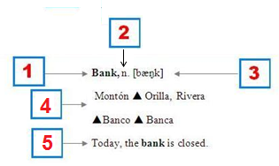

- ( ) Pronunciation.
- ( ) Translation / Meaning.
- ( ) Entry word.
- ( ) Example sentence.
- ( ) Part of speech.

II. Match the components and entry words.
- |breik| v. romper, partir, quebrar. 2 MED. Fracturar, romper (un hueso). 3 (fig.) romper, no cumplir (promesa), infringir (ley).  - |bres| s.c. 1 pecho, seno, mama. 2 pecho (de hombre). 3 pechuga (de ave).  - |bred| s.i. 1 pan. 2 sustento, comida, pan. The bread is baked in an oven = El pan es horneado en un horno.  - |breiv| adj. 1 valiente, esforzado. 2 magnifico, esplendido. v.t. 3 afrontar. | - ( ) Brave.  - ( ) Breast.  - ( ) Bread.  - ( ) Break.

III. Identify the correct meaning of the word in capital letters of each sentence. Circle the correct answer. You can use your dictionary.

- I hate it when a FLY lands in my soup!
- Move through the air.
- Insect.

- Did you CLOSE the door after you?
- Shut.
- Near.

- The BAT flew at night.
- A flying mammal.
- A piece of sporting equipment.

- Can you turn off the FAN, please?
- Admirer.
- A cooling device.

- Cinderella wanted to go the BALL too.
- Dance.
- Toy.

