Trabajo de recuperación de inglés – Primer grado
Tema: “Forecast”
Nombre del alumno(a): __________________________________________________
No. Lista: ____Grupo: “____” Turno: ____

I. Match the predictions with the images.

- She is sick. She will see a doctor tomorrow.  - The girl will finish her homework.  - George will drink that lemonade.  - It will be cloudy.  - He will travel to a foreign country. |  | - ( )
 |  | - ( )
 |  | - ( )
 | 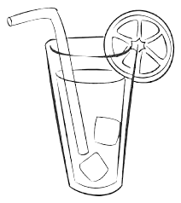 | - ( )
 |  | - ( )

II. Put the verb in the correct form. Use simple future.
Affirmative form
Example: Carol is thirsty. She _will drink_ (to drink) a coke.
- Today, we ______________________ (to have) a delicious breakfast.
- Next Christmas, I ______________________ (to spend) the holidays with my family.
- Hurry up or you ______________________ (to miss) the bus.
Negative form
Example: The baby __won’t cry__ (to cry) if you give her milk.
- She ______________________ (to travel) to France next year.
- I ______________________ (to work) as an engineer.
- It ______________________ (to rain) tomorrow.
Interrogative form
Example: __Will__ she _visit_ your parents next summer? (to visit)
- ___________ you __________________ shopping tomorrow? (to go)
- ___________ you __________________ the exam? (to pass)
- ___________ Natasha __________________ elementary school? (to finish)

III. Look at the images and make the predictions.

 |  |  | He will drink a soda.
1 |  |  | It will ___________
2 |  |  | They _________ _________________________
3 |  |  | __________________________________________________________________________________
4 |  |  | __________________________________________________________________________________

