Trabajo de recuperación de inglés – Primer grado
Tema: “Human body systems”
Nombre del alumno(a): __________________________________________________
No. Lista: ____Grupo: “____” Turno: ____

I. Label the human body systems.
Digestive – Skeletal – Nervous – Respiratory – Excretory – Circulatory - Muscular

_______________ | _______________ | _______________ | ______________

___________________ | ___________________ | ___________________

II. Label the internal organs.
Large Intestine – Heart – Lung – Brain – Liver – Stomach – Kidney – Small Intestine

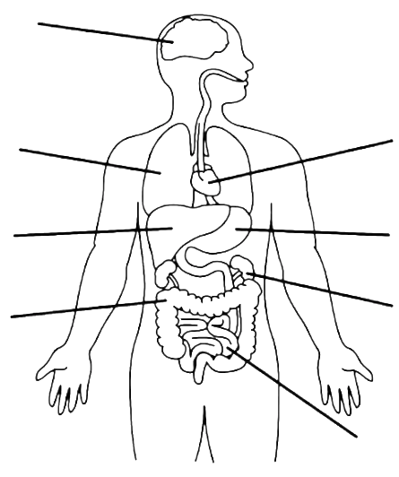
III. Circle the correct form of the verb
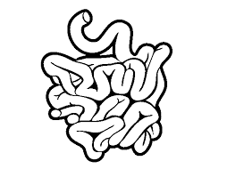 | - The small intestine a b s o r b / a b s o r b s the nutrients from the food.
 | - The heart p u m p / p u m p s blood through the body.
 | - The lungs h e l p / h e l p s the body to get rid of CO₂ gas.
 | - The stomach p r o c e s s / p r o c e s s e s the food.
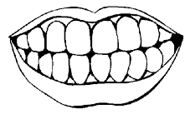 | - The teeth c h e w / c h e w s the food.

IV. Unscramble the sentences.

Example: filter / the waste / from the blood / The kidneys / products
The kidneys filter the waste products from the blood.

1. The brain / the body / controls

__________________________________________________________
2. heart / pumps / blood / The

__________________________________________________________

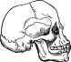 | 3. brain / skull / protects / The  __________________________________________________________
4. CO₂ / breathe in oxygen / The lungs / and breathe out

__________________________________________________________

