Trabajo de recuperación de inglés – Primer grado
Tema: “Likes and dislikes”
Nombre del alumno(a): __________________________________________________
No. Lista: ____Grupo: “____” Turno: ____

I. Label the images.

Read – Skate – Play – Swim – Watch – Sing – Ride – Do – Listen

_________________ | _________________ | _________________
 |  | 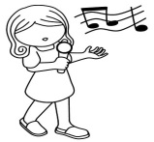
_________________ | _________________ | _________________
 |  | 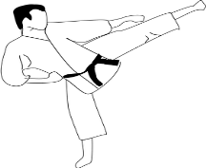
_________________ | _________________ | _________________

II. Look at the images and complete the sentences.
to read – to do – to listen - to play (x2)

 | - I like ___t o s w i m ___ in the lake.
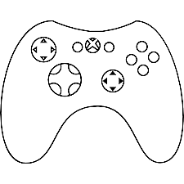 | - I don’t like _______________ videogames.
 | - I love _______________ to music.
 | - I hate _______________ books.
 | - I like _______________ karate.
 | - I don’t like _______________ chess.

III. Unscramble the sentences.
1. to play / I / like / volleyball
________________________________________________________________________
2. play / don’t / like / I / to / video games
________________________________________________________________________
3. listen / to / don’t / to / rock music / I / like
________________________________________________________________________
4. I / shower / to / in the / sing / like
________________________________________________________________________
5. guitar / like / don’t / the / I / play / to
________________________________________________________________________

