Trabajo de recuperación de inglés – Segundo grado
Tema: “Newspaper publications”
Nombre del alumno(a): __________________________________________________
No. Lista: ____Grupo: “____” Turno: ____

I. Label the sections of a newspaper.
international news – local news –
classified ads – society – politics - sports

_____________________ | _____________________ | _____________________
_____________________ | _____________________ | _____________________

II. Match the headings with the newspaper sections.
- Local team scored a goal in the last minute.  - Five things to see at the architecture festival.  - México deports 311 Costa Ricans attempting to illegally enter the US.  - $1,000 a day to start. No experience necessary.  - Snowstorm closes North Dakota interstates. | - ( ) Sports.  - ( ) International news.  - ( ) Classified ads.  - ( ) Weather.  - ( ) Arts/Culture.

III. Identify the parts of a newspaper. Match the numbers (1-8) with the parts.
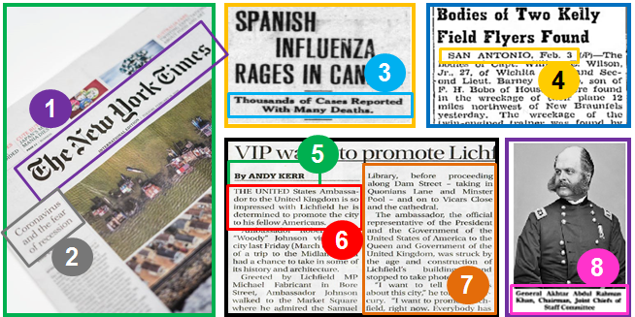

- Dateline ____
- Headline ____
- Byline ____
- Body ____
- Dropline ____
- Lead ____
- Name of the newspaper ____
- Caption ____

IV. Match the newspaper headlines that are about the same topic.
- 1,492 go down to their death in loss of Titanic  - Thousand feared dead in terrorist attack  - Men walk on the moon  - World war is over  - Flying machine takes to the air | - ( ) More than 1,500 perish as the great ship sinks  - ( ) Astronauts land on a plain after steering past crater  - ( ) Armistice is signed. Germany surrenders.  - ( ) Successful trial of flying machine made by Wright  - ( ) U.S. attacked

