Trabajo de recuperación de inglés – Segundo grado
Tema: “Autobiographical anecdote”
Nombre del alumno(a): __________________________________________________
No. Lista: ____Grupo: “____” Turno: ____

I. Label the verbs.
washed – bought – drank – ate – went – watched – listened - read

1 | 2 | 3 | 4
 |  |  | 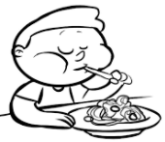
________________ | ________________ | ________________ | ________________
4 | 5 | 6 | 7
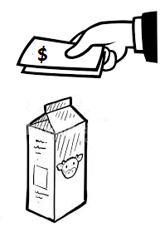 |  | 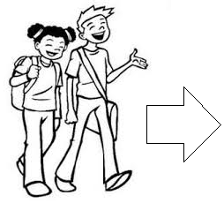 | 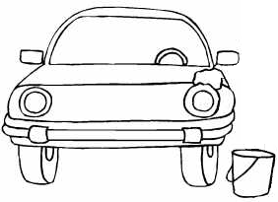
________________ | ________________ | ________________ | ________________

II. Complete the sentences.
watched - played – died – bought – ate

- Last night, I _____________ baseball with my friends.
- My best friend _____________ of COVID-19 in 2020.
- We _____________ TV all evening because there was a Games of Thrones marathon.
- My family and I _____________ sea food in a nice restaurant and we
drank coconut water.
- I _____________ some milk and bread in the store yesterday.

III. Match the sentences with the adverbs of time/time expressions.
1. I didn’t play video games with my friend Carl _____.  2. The last _____, I went to the beach with my family.  3. This happened a long time _____, I think when I was eleven years old.  4. We talked for hours on the phone _____ night.  5. It happened several _____ ago in my birthday party. | - ( ) years.  - ( ) ago.  - ( ) yesterday.  - ( ) last.  - ( ) summer.

IV. Circle the correct answer.
- I _____ born in Tijuana.
- were
- was

- She _____ happy because it was her birthday.
- was
- were

- They _____ at home last night.
- were
- was

- It _____ easy for her to raise a child and a teenager but she did it.
- weren't
- wasn't

- Carol and Anne _____ happy for his promotion.
- weren’t
- wasn’t

- I didn't buy those jeans because they _____ too expensive.
- were
- was

