Trabajo de recuperación de inglés – Tercer grado
Tema: “Cultural habits”
Nombre del alumno(a): __________________________________________________
No. Lista: ____Grupo: “____” Turno: ____

I. Label the aspects of culture.

Clothing – Art – Language – Music – Religion - Food

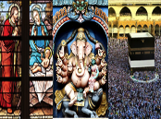 | 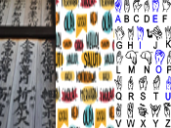 | 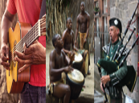
_____________________ | _____________________ | _____________________
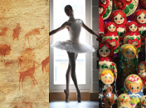
_____________________ | _____________________ | _____________________

II. Match the descriptions with the holidays.
- People wear an item of green clothing on this day.  - The lighting of oil lamps is used to represent the triumph of the good over evil.  - Roasted turkey is the main dish that is served on this holiday.  - Chocolates and romantic cards are given to express love to others.  - People often dress up scary costumes and ask people for trick or treat. | - ( ) St. Patrick’s day.  - ( ) Thanksgivig.  - ( ) Halloween.  - ( ) St. Valentine’s day.  - ( ) Diwali.

III. Fill in the blanks with the following words:
vampires - October – treat – 2000

Halloween is celebrated on 1) __________________ 31st. It was originally a pagan holiday that honored the dead. Halloween refers to “All Hallows Evening “, and dates back to over 2) __________________ years ago.

Children dress up as witches, ghosts or 3) __________________and they go from house to house playing trick or 4) __________________.

IV. Write "F" for fact or "O" for opinion to the statements.
- Halloween is the most important holiday of the year. ____
- Soccer is the most popular sport in the U.S. ____
- Christmas is celebrated on December 25th. ____
- On the Day of the dead, the bread symbolizes a fraternal offering to the souls. ____

V. Fill in the blanks with the following words:

much - where - who - what - why - many - how - when

- _______________ is Halloween? -It's a popular holiday where children dress up in scary costumes.
- _______________ do people celebrate Halloween? -On October 31st.
- _______________ Halloween is celebrated? -Many Americans celebrate by dressing in costumes and telling tales of witches and ghosts.
- How _______________ Halloween movies are there? -There are 13 movies.
- How _______________ do Americans spend on Halloween? -They spend 9 billion on costumes, candies and decorations.
- _______________ wrote the novel Frankenstein? -Mary Shelley.

