Trabajo de recuperación de inglés – Tercer grado
Tema: “Science Experiments”
Nombre del alumno(a): __________________________________________________
No. Lista: ____Grupo: “____” Turno: ____

I. Label the verbs.
squeeze – fill- mix – add – hold – cut – drop – shake - blow up

_____________________ | _____________________ | _____________________
 | 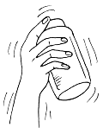 | 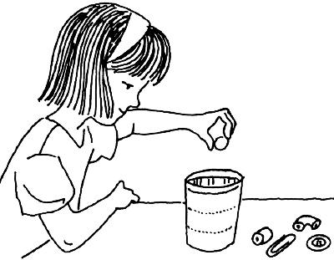
_____________________ | _____________________ | _____________________
_____________________ | _____________________ | _____________________

II. Label the vocabulary of experiments.
magnet – bottle – glass – scissors – bowl – balloon

_____________________ | _____________________ | _____________________
_____________________ | _____________________ | _____________________

III. Match the images with the instructions.
- ( ) Stir the sugar and salt in the water.
- ( ) Pour the mixture into the bowl.
- ( ) Squeeze the lemon.
- ( ) Fill a glass with water.

IV. Put the steps of the experiment in order (1-5).

Name of the experiment: Make a ping pong ball float

Steps:
- ( ) Finally, watch what happens.
- ( ) Put it on the highest setting and point it straight up.
- ( ) Place your ping pong ball above the hair dryer
- ( ) First, plug in the hair dryer.
- ( ) Then, turn the hair dryer on.
V. Unscramble the sentences.
- in / mix / the ingredients / a bowl

________________________________________________
- food coloring / add / drops / three / of

________________________________________________
- the mixture / pour / into the / bowl

________________________________________________
- water / fill / with / the glass

________________________________________________

