Trabajo de recuperación de inglés – Tercer grado
Tema: “Hypotheses about past events”
Nombre del alumno(a): __________________________________________________
No. Lista: ____Grupo: “____” Turno: ____

I. Write "F" for fact or "O" for opinion to the statements.
Cleopatra was the queen of Egypt. ____
Stonehenge is one of the world’s most famous monuments. ____
Cleopatra was the most beautiful and powerful queen known to mankind. ____
Stonehenge was built as a burial site. ____
There are 900 statues in Rapa Nui. ____
The Bermuda triangle is called the Devil's triangle. ____

II. Complete the crossword using Wh-question words such as what, where, when, why, who, how, etc.

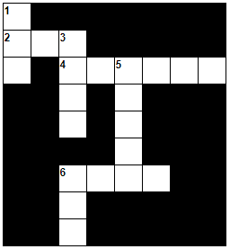 | ACROSS :  2. _____ do they know there were golden coins? –The pirates told them.  4. _____ were the footprints?  –Not too much. They were small.  6. _____ was the murder of Mr. Donahue? –Last night.
DOWN :
1. _____ is she? –She’s the wife.
3. _____ did the survivors say?
–They said it was a mystery.
5. _____ did she meet Robbie?
–At university.
6. _____ were the windows open?
–Nobody knows.

III. Fill in the blanks with the following verbs:

broke - was - had - used - seen - read

- Maybe it _______________ dark and the floor was very wet.
- She might have been _______________ the reflection of herself.
- Maybe the murderer ran fast and _______________ the lamp.
- The thief might not have _______________ the letter.
- Maybe he _______________ a relationship with her.
- The murderer might have _______________ the knife to kill her.

IV. Circle the correct answer.
1. ______ did the murderer escape from the cell? -He used a shovel.
a) What b) Where c) How
2. ______ money did the thief steal? -5,000 dollars.
a) Which one b) How much c) What the
3. ______ it was a virus.
a) Might b) Guess c) Maybe
4. She might ______ taken the bus. We're not sure how she got to work.
a) has b) have c) had
5. The murderer might have ______ a gun to kill him.
a) used b) use c) to use

