SCHOOL NAME

ENGLISH I

FIRST GRADE

UNIT 1 PART 1

PROJECT

“INSTRUCTION MANUAL TO LEARN HOW TO USE A BILINGUAL DICTIONARY”

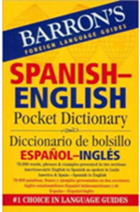

STUDENTS´ NAMES No.

_________________________________________________________________ _____

_________________________________________________________________ _____

_________________________________________________________________ _____

_________________________________________________________________ _____

GROUP:

SHIFT:

WHAT IS A BILINGUAL DICTIONARY?
Complete the definition.
translate – word – verb tables

  - A bilingual dictionary is a specialized dictionary used to ________________ words or phrases from one language to another. It helps a non-native speaker how to use a ________________.
  - You can find in these dictionaries: lists of phrases, ________________, maps and grammar references. In contrast to the bilingual dictionary, a monolingual dictionary defines words and phrases instead of translating them.

CHOOSE THE RIGHT DICTIONARY - TYPES OF DICTIONARIES
Identify the types of dictionary. Use the images.

M o n o l i n g u a l | B i l i n g u a l | Pictionary  (Picture Dictionary)
Pega aquí la  imagen correspondiente  Ve a los anexos en la última hoja  This dictionary defines words and phrases using the same language. | Pega aquí la  imagen correspondiente  Ve a los anexos en la última hoja  This dictionary translate the words or phrases from one language to another | Pega aquí la  imagen correspondiente  Ve a los anexos en la última hoja  It´s a dictionary where the definition of a word is displayed in the form of a drawing or photograph.

IDENTIFY THE PARTS OF A BILINGUAL DICTIONARY
  - Identify the parts of a bilingual dictionary.

Pronunciation - Entry word – Meaning - Example sentence - Part of speech – Guide words – Page number

APPLAUSE – APPLIANCE 22
…
Apple, n. [ˈӕpl]
Manzana
The apple is a fruit.

LEARN THE ABBREVIATIONS 1
  - Complete the tables.
Español |  |  | English
Abreviatura | Significado |  | Abbreviation / Part of speech | Meaning
1. adj. | adjetivo |  | 1. adj. | adjective
2. s. / sust. |  |  | 2. n.
3. v. |  |  | 3. v.
4. pron. |  |  | 4. pron.

LOOK UP A WORD
Complete the table.
Entry word | Meaning of the word | Part of speech
 |  | Spanish | English
1. Banana | Plátano | Sustantivo | Noun
2. He | Él | Pronombre | Pronoun
3. Study
4. Big
5. She
6. Mango

FOLLOW THE ALPHABETICAL ORDER

Rewrite the list of words in alphabetical order.
- Cat  - I  - Bat  - Wireless  - Animal  - Run  - Small  - Table  - Cow  - Frog  - Zoo | - _Animal____________  - _Bat_______________  - ___________________  - ___________________  - ___________________  - ___________________  - ___________________  - ___________________  - ___________________  - ___________________  - ___________________

CLASSIFY THE WORDS

Complete the list of words according to its part of speech. Use your dictionary.

Nouns | Verbs | Adjectives
_________cat________  ___________________  ___________________  ___________________ | _________play__________  ______________________  ______________________  ______________________ | ________beautiful_______  ______________________  ______________________  ______________________

IDENTIFY THE PART OF SPEECH OF THE WORD
Complete the table.
Entry word | Image | Part of speech  (Noun/Verb/Pronoun/Adjective) | Meaning
1. Eat |  | _____________verb______________ | _____________comer_____________
2. Pen |  | ______________________________ | ______________________________
3. Big |  | ______________________________ | ______________________________
4. Circus |  | ______________________________ | ______________________________
5. They |  | ______________________________ | ______________________________
6. She |  | ______________________________ | ______________________________
7. Drink |  | ______________________________ | ______________________________
8. Rabbit |  | ______________________________ | ______________________________

USE THE GUIDE WORDS
Categorize the words according to the alphabet grouping.

dog – green - eat – tiger – big – monkey – he – nice – small –
water – lemonade - purple - yellow – cow

A-C | D-F | G-J | K-M | N-Q | R-U | V-Z

Guide words are the two words at the top of the page that tell you what words are on the page. For example:
RED-REDIAL 355 | CAT-CATERPILAR 150

Look up each word below in your dictionary. Write the guide words and page number for each word.

Entry word | Page | Guide word #1 | Guide word #2
- house  - like  - we  - easy | ____  ____  ____  ____ | _________________________  _________________________  _________________________  _________________________ | _________________________  _________________________  _________________________  _________________________

LEARN THE ABBREVIATIONS 2
Match the abbreviations with the meanings.

- Abbr.  - Adj.  - Adv.  - AmE.  - BrE.  - C.  - Conj.  - Det. | - _____ Adjective  - _____ American English  - _____ Countable Noun  - _____ Determiner  - _____ Conjunction  - _____ British English  - _____ Adverb  - _____ Abbreviation | - Pl.  - Pron.  - Pt.  - Sing.  - Sth.  - U.  - N.  - Prep.  - Adv. | - _____ adverb  - _____ preposition  - _____ noun  - _____ uncountable  - _____ something  - _____ singular  - _____ past tense  - _____ pronoun  - _____ plural

Use your dictionary and write 5 more abbreviations.
- _________ _____________________________
- _________ _____________________________
- _________ _____________________________
- _________ _____________________________
- _________ _____________________________

INSTRUCTIONS TO USE A BILINGUAL DICTIONARY
According to the activities below and the class activities, now list the instructions to use a bilingual dictionary.

ANNEXES

Recorta estas imágenes y pégalas en la parte de: Types of dictionaries

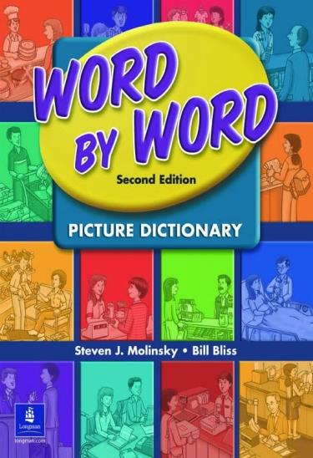 | 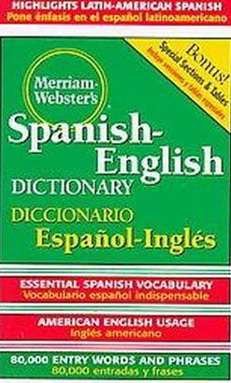 | 