|  |
| --- |
| Pop Quiz – 3rd Grade Unit 2 (Emotions)  Name: ____________________________________________ Group: _____ No. ___ |

**Circle the correct answer.**

1. What are these emotions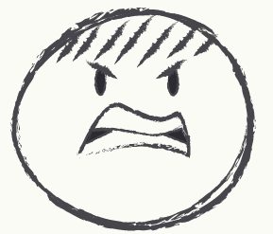?

a) angry-thirsty b) sad-angry c) thirsty-hungry

1. People said she was a witch, nobody was brave enough, so people were…

a) confused b) scared c) happy

1. She was _____ because she lost the race.

a) happy b) excited c) sad

1. He was very _____ because she fell in love with him.

a) frightened b) shocked c) happy

1. She was late. She knew she’d get in trouble She was _____

a) excited b) ok c) worried

1. The girl was sleeping when she heard something strange under the bed. She was _____ because no one else was home.

a) shocked b) excited c) overjoyed

1. Which emotion shows unhappiness?

a) sad b) happy c) angry

1. Which is the antonym for sad?

a) happy b) angry c) surprised

1. After his mother died of cancer, Michael was _____

a) excited b) devastated c) cool

1. Elias laughed when Amelia said that. He was a brave man. He was not _____ of a cat.

a) good b) worried c) afraid

|  |
| --- |
| Pop Quiz – 3rd Grade Unit 2 (Emotions)  Name: ____________________________________________ Group: _____ No. ___ |

**Circle the correct answer.**

1. What are these emotions?

a) angry-thirsty b) sad-angry c) thirsty-hungry

1. People said she was a witch, nobody was brave enough, so people were…

a) confused b) scared c) happy

1. She was _____ because she lost the race.

a) happy b) excited c) sad

1. He was very _____ because she fell in love with him.

a) frightened b) shocked c) happy

1. She was late. She knew she’d get in trouble She was _____

a) excited b) ok c) worried

1. The girl was sleeping when she heard something strange under the bed. She was _____ because no one else was home.

a) shocked b) excited c) overjoyed

1. Which emotion shows unhappiness?

a) sad b) happy c) angry

1. Which is the antonym for sad?

a) happy b) angry c) surprised

1. After his mother died of cancer, Michael was _____

a) excited b) devastated c) cool

1. Elias laughed when Amelia said that. He was a brave man. He was not _____ of a cat.

a) good b) worried c) afraid