ENGLISH EXAM – FIRST GRADE
UNIT 1 (COMMUNITY SERVICE)
STUDENT’S NAME: _______________________________________ GROUP: _______ TEACHER’S NAME: _____________________________ DATE: ___________________

SCORE:

MARK YOUR ANSWERS HERE
1
2
3
4
5
6
7
8
9
10

INSTRUCTIONS: CHOOSE THE CORRECT ANSWER.
PART 1

- Match the community services with the pictures.

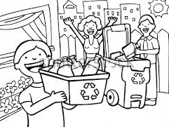  A | B

- A-Collect garbage B-Litter patrol
- A-Litter patrol B-Recycling
- A-Recycling program B-Donate food
- A-Burn bottles B-Collect cans

- Match the activities for the community services with the pictures.

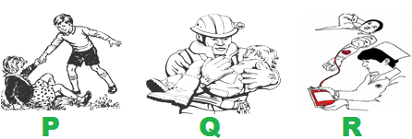

- P- Help Q- Rescue R-Donate
- P- Rescue Q- Help R-Donate
- P- Donate Q- Rescue R-Help
- P-Rescue Q- Donate R-Help

- COMMUNITY SERVICE: People ____ animals in my city.

- recycle
- donate
- adopt
- kill
- COMMUNITY SERVICE: My family ____ in the forest.

- collect stamps
- raise money
- plant trees
- burn garbage

- COMMUNITY SERVICE: In my school we ____ plastic bottles

- eat
- recycle
- love
- burn

- Complete the conversation.

A: ____, Henry, what are you doing?
B: Hi, Sally. I´m making a list of thing we can recycle in my ____.
A: It sounds interesting. Do you need _____?
B: Yeah, why not? Do we can recycle paper?
A: Yes, we can. In my school we always recycle the _____.

- Bye – house – water - garbage
- Hello – community – help – books
- Hey – kitchen – money – spoons
- How – backpack – police - pencils

- Put in order the conversation.

P- Good morning! How can I help you?
Q- I would like to work in a community service.
R- Human community care.
S- What kind of community service?

- P, Q, R, S
- S, R, P, Q
- P, Q, S, R
- S, P, Q, R

- If you need a book then go to a ______.

- Pharmacy
- Music shop
- Library
- Post office

- If you want to buy a new CD, the best place to go is the ______.

- Library
- Post office
- Pharmacy
- Music shop

- Where can I go for aspirin?
The best place to go might be the ______.

- Music shop
- Library
- Post office
- Pharmacy

