ENGLISH EXAM – FIRST GRADE
UNIT 2 (CLASSIC TALES)
STUDENT’S NAME: _______________________________________ GROUP: _______ TEACHER’S NAME: _____________________________ DATE: ___________________

SCORE:

MARK YOUR ANSWERS HERE
1
2
3
4
5
6
7
8
9
10

INSTRUCTIONS: CHOOSE THE CORRECT ANSWER.
PART 2

- Which classic tale is about a girl who lives with seven dwarves and one day she eats a poisoned apple and falls sleep and wakes up with the kiss of a real love?

- Sleeping beauty.
- Snow white.
- Juliet and Romeo
- Three little pigs

- Complete the plot of the following tale.

This tale is about a hungry ___________ who wants to _____________ three pigs.

- robot - analyze
- cabin - lock
- wolf – eat
- princess – dance with
- Look at the picture and choose the correct option to describe the event of the classic tale.

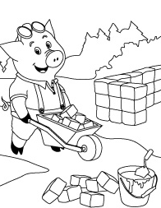

- He sang and danced all day.
- He met the big bad wolf.
- He built his house with bricks.
- He started working in the factory.

- In the tale “Three little pigs”, who was the villain?

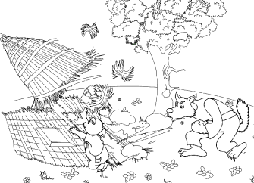

- The little pig.
- The wolf.
- The weather.
- The lion.

- Read the fragment of the classic tale “three little pigs” and answer the question.
Once upon a time there were three little pigs.
One pig built a house of straw while the second pig built his house with sticks. The third little pig worked hard all day and built his house with bricks.

What was the first little pig’s house made of?

- Brick.
- Straw.
- Stick.
- Stone.

- Read the fragment of the classic tale “snow white and the 7 dwarfs” and answer the question.
One day, the Prince was riding through the forest looking for Snow White and found her. He leaned over and kissed her.
She opened her eyes and sat up with a smile.
Everyone was happy. The Prince took Snow White to his palace where they were married and lived happily ever after.

What was the prince looking for in the forest?

- The evil witch.
- The palace.
- The 7 dwarfs
- Snow White.

- Who are the main characters in the tale “Three little pigs”?

- The three houses.
- The 3 pink rats and the wolves.
- The three little pigs and the big bad wolf.
- The grandmother and the woodcutter.
- Why couldn't the Wolf blow down the third little pigs' house?

- The wolf was out of breathe
- He was tired and hungry
- It was made out of bricks
- He needed extra help

- Put in order the following events of the classic tale “three little pigs”.

R – One pig built a house of straw.
S – The big bad wolf went to the first house and huffed and puffed and blew the house down in minutes.
T- Once upon a time there were three little pigs.
- R, S, T
- T, R, S
- R, T, S
- T, S, R

- Put in order the following events of the classic tale “little red riding hood”.

R – “What big eyes you have?” said little red riding hood.
S – On her way she met the big bad wolf.
T- Once upon a time a girl called little red riding hood.

- R, S, T
- T, S, R
- R, T, S
- S, T, R

