ENGLISH EXAM – FIRST GRADE
UNIT 3 (INSTRUCTION MANUAL)
STUDENT’S NAME: _______________________________________ GROUP: _______ TEACHER’S NAME: _____________________________ DATE: ___________________

SCORE:

MARK YOUR ANSWERS HERE
1
2
3
4
5
6
7
8
9
10

INSTRUCTIONS: CHOOSE THE CORRECT ANSWER.
PART 1

- Which ones are types of dictionaries?

- Stories, Novel and Fable.
- Monolingual, Bilingual and Pictionary.
- Bible and Journals.
- Magazine and Newspaper.

- Which words are nouns?

- pencil, chicken, castle & chair
- on, under, next to & in
- big, tall, short & large
- write, eat, read & play
- Which words are verbs?

- rat, cat, car & rap
- small, beautiful & ugly
- read, hate, run & love
- he, she, it, we, they & you
- Match the dictionary components.

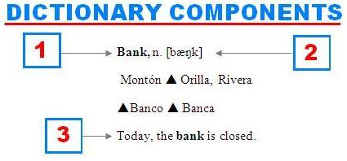
- 1-Headword / 2-Part of speech / Translation
- 1-Bank / 2-Pronunciation / 3-Statement
- 1-Entry word / 2-Pronunciation / 3-Example sentence
- 1-Noun / 2-Part of speech / 3-Full sentence

- Match the dictionary components.
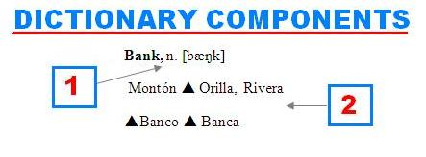
- 1-Noun / 2-Example sentence
- 1-Part of speech / 2-Translation
- 1-Pronunciation / 2-Spanish version
- 1-Verb / 2- Nouns

- Choose the correct option in order to complete the table.

Abbreviation | Meaning
1. Adj
2. n
3. v.
4. pron.

- abjective – noon – verb – proname
- adjetive – nuon – verb – prooun
- adjective – noun – verb – pronoun
- adjetive – nooun – verb – pronomb

- Match the abbreviations with the meaning.

- AmE.  - Sing.  - Adv.  - C. | R. Countable  S. American English  T. Adverb  U. Singular

- 1R, 2S, 3T, 4U
- 1U, 2S, 3R, 4T
- 1T, 2U, 3S, 4R
- 1S, 2U, 3T, 4R

- The following list of words is organized according to:
Cat
Dog
Fox

Play
Eat
Write

- Alphabetical order
- Nouns and verbs
- Animals and adjectives
- Best and worst

- Which words are in alphabetical order?

- cat, sweet, under, two, red.
- big, green, monkey, she, zoo.
- ant, beautiful, elephant, dinosaur, frog.
- bee, blue, keyboard, sport, on.

- If you look up the word “MANGO” in a dictionary, which GUIDE WORDS will you find?

- RED-ROTTEN
- MAN-MEETING
- CAT-CEILING
- MEN-MOON

