ENGLISH EXAM – SECOND GRADE
UNIT 1 (GOODS CATALOGUE)
STUDENT’S NAME: _______________________________________ GROUP: _______ TEACHER’S NAME: _____________________________ DATE: ___________________

SCORE:

MARK YOUR ANSWERS HERE
1
2
3
4
5
6
7
8
9
10
11
12

INSTRUCTIONS: CHOOSE THE CORRECT ANSWER.
PART 1

- Which store is Tom in?

Tom: | Excuse me. Can you help me?
Assistant: | Certainly. What can I do for you?
Tom: | I’m looking for a sweater.
Assistant: | What’s your size?
Tom: | I’m medium.

- Fruit shop
- Shoe store
- Clothing store
- Hardware store

- Complete the conversation.

Clerk: | _____ I help you?
Mary: | Yes, how _____ is this dress?
Clerk: | It’s $89.
Mary: | Can I _____ on?
Clerk: | Yes, what size are you?
Mary: | I don’t know. I think I’m a size _____.

- what – are – size - 12
- do – cost – use - medium
- how – is – put - please
- can – much – try - ten

- John, I need your help. Which sofa should I buy? I can’t decide! This one is larger, but it’s more expensive.

Which phrase expresses a suggestion?

- This one is larger.
- I need your help.
- Which sofa should I buy?
- I can’t decide!

- This dark sweater isn’t colorful, _____ it’s trendier than the others.

- and
- but
- or
- of

- Match the items with the adjectives.

R) Shoes  S) Candies  T) Book | 1) Sweet  2) Comfortable  3) Interesting

- R1, S2, T3
- R2, S1, T3
- R3, S3, T2
- R3, S2, T3

- Look at the image and complete the expression.
“I like _____ T-shirt”

- this
- these
- that
- those

- Look at the image and complete the expression.
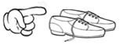

“How much are _____ shoes?”

- this
- these
- that
- those

- Complete the following statements with the correct form of verb to be.

“The white dress _____ trendy.
This perfume _____ too expensive.
These jeans _____ really tight”

- are, is, is
- is, are, are
- is, is, are
- are, are, is

- Rewrite the sentences using one/ones.

I like these _____ (apples).
How much is that _____ (umbrella)?
She’s looking for a pink _____ (dress).

- one, ones, ones,
- ones, one, one
- one, one, ones
- ones, ones, one

- Which one of the following statements is correct? Look at the images.
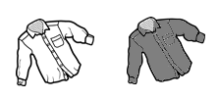
$45 $55

- The white shirt is more expensive than the gray one.
- The gray shirt is the cheapest.
- The white shirt is as expensive as the gray shirt.
- The gray shirt is more expensive than the white one.

- Complete the comparison. Look at the images.

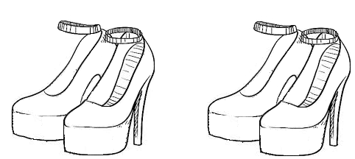
Red Black

“The red high heels _____ black ones”

- is the comfortabler that
- are more comfortable than
- than comfortable that
- are the most comfortable

- Complete the comparisons.

“This skirt is _____(pretty) than this one. These blouses are _____ (trendy) than the purple ones. And that handbag is _____ than this”

- prettier – more trendy – biger
- more pretty – trendier – more big
- prettier – trendier - bigger
- prettiest – trendiest – biggest

