ENGLISH EXAM – SECOND GRADE
UNIT 2 (COMIC STRIP)
STUDENT’S NAME: _______________________________________ GROUP: _______ TEACHER’S NAME: _____________________________ DATE: ___________________

SCORE:

MARK YOUR ANSWERS HERE
1
2
3
4
5
6
7
8

INSTRUCTIONS: CHOOSE THE CORRECT ANSWER.
PART 2

- Match the pictures with the adjectives.

1 | 2 | 3

- 1 Weak, 2 Pretty,3 Old
- 1 Handsome, 2 Ugly, 3 Beautiful
- 1 Strong, 2 Beautiful, 3 Ugly
- 1 Brave, 2 Evil, 3 Kind

- Which fantasy character is? Look at the list of adjectives and choose the character that describes.

Old, ugly, evil, wicked, black, female, mean, cruel & wrinkled.

- Unicorn
- Gnome
- Princess
- Witch

- Which are the elements of a comic strip?

- Beginning, middle and end.
- Scooby Doo, Shaggy, Daphne, Fred and Velma.
- Panels, layouts, drawings, speech balloons and characters.
- Code, name of the product, size, color and price.

- Look at the part of the comic strip and choose the right option to complete what the character said.

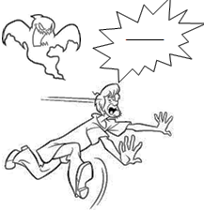

- Help!
- Good morning.
- I’m hungry.
- Delicious!

- Choose the correct bubble speech for this panel of the comic strip.

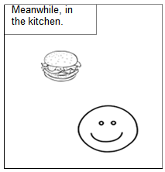

- Choose the correct bubble speech for this panel of the comic strip.

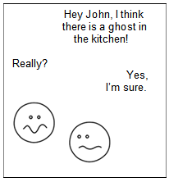

- Put in order the panels of the comic.
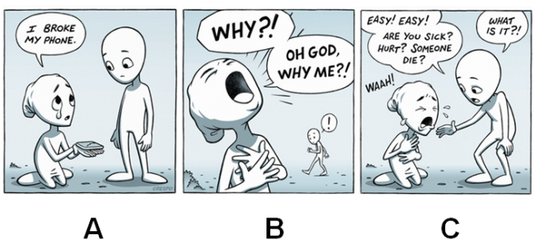

- A, B, C
- B, C, A
- B, A, C
- C, B, A

8. Complete the panel.

Once upon a time there was a 1)____ princess named Farah, who 2)____ in a big palace. When she was 15, a horrible witch put a curse on 3)____.

- 1-beautiful 2-lives 3-her
- 1-story 2-is 3-castle
- 1-in 2-on 3-into
- 1-strong 2-likes 3-him

