ENGLISH EXAM – SECOND GRADE
UNIT 3 (INSTRUCTION MANUAL)
STUDENT’S NAME: _______________________________________ GROUP: _______ TEACHER’S NAME: _____________________________ DATE: ___________________

SCORE:

MARK YOUR ANSWERS HERE
1
2
3
4
5
6
7
8
9
10

INSTRUCTIONS: CHOOSE THE CORRECT ANSWER.
PART 1

- Look at the manual in case of emergency and identify the part in the square.

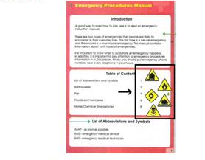

- Abbreviations
- Title
- Illustrations
- Introduction

- The following image is used in one environmental emergency. Which one is it?
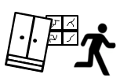

- Flood
- Earthquake
- Influenza
- Oil spill

- Look at the emergency sign and choose the correct meaning.

- Avoid contact with sick people
- Provide first aids
- Stay away from danger
- Do not help others

- Look at the emergency sign and choose the correct meaning.

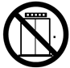

- Use stairs
- Open the doors
- Do not use elevators
- No trespassing

- Match the instructions with the pictures:
1  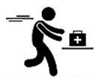 | 2  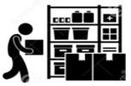 | 3  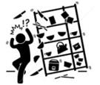
- Store food and medicines
- Do not climb
- Stay away from dangerous objects
- Take first aid kit with you

- 1A, 2B, 3D
- 1C, 2D, 3A
- 1D, 2A, 3C
- 1B, 2C, 3A
- Read the instruction and choose the correct sign.
“Crawl through the smoke”

- 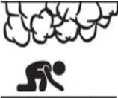
- 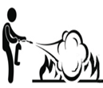
- 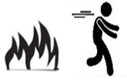
- 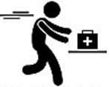

- Read the instruction and choose the correct sign.
“Do not drive into flooded areas”

- 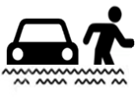
- 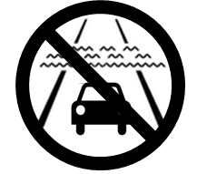

- Choose the correct instruction in case of tsunami.

- Go to the beach
- Surf the waves
- Move to higher grounds
- Use the fire extinguisher

- Choose the correct option in order to complete the instruction to face a tsunami event.

- Walk, Buy, Go
- Make, Sell, Prepare
- Go, Make, Contact
- Escape, Try, Stay away from

- Choose the correct instruction in case of influenza.

- Use flashlights
- Protect your home
- Pull alarm
- Wash hands

