ENGLISH EXAM – SECOND GRADE
UNIT 5 (HANGMAN/RHYTHM, STRESS & INTONATION)
STUDENT’S NAME: _______________________________________ GROUP: _______ TEACHER’S NAME: _____________________________ DATE: ___________________

SCORE:

MARK YOUR ANSWERS HERE
1
2
3
4
5
6
7
8

INSTRUCTIONS: CHOOSE THE CORRECT ANSWER.
PART 1

- Match the games with the images.

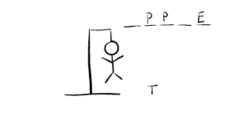 |  | 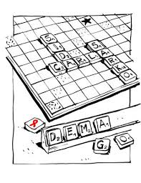
X | Y | Z

- Ladders & Snakes
- Hangman
- Scrabble
- Chess

- X1, Y2, Z4
- X2, Y4, Z1
- X2, Y1, Z3
- X3, Y2, Z1

- Label the parts of the hangman game.

V. Gallows
W. Hanging figure
X. Dashes
Y. Letters
Z. Wrong letters

- 1V, 2W, 3X. 4Z, 5Y
- 1W, 2V, 3Z, 4Y, 5X
- 1X, 2V, 3Z, 4W, 5Y
- 1V, 2W, 3X, 4Y, 5Z

- Choose the group of words that contains stressed words (content words).

- I, you, she, him, us, & ours.
- Sam, castle, eat, & always.
- and, so, but, not & however.
- at, on, to & near.

- Label the content words.

X | Y | Z
Alice  Love | Dance  Eat | Beautiful  Expensive

- Nouns
- Adjectives
- Adverbs
- Verbs

- X2, Y4, Z3
- X3, Y2, Z1
- X4, Y1, Z2
- X1, Y4, Z2

- Identify the stressed words in the following sentence.

“What did you do yesterday?”

- What – did – yesterday
- did – you – do
- What – do – yesterday
- did - do – yesterday

- Which one is the correct word stress for “democracy”?

- de-moc-RA-cy
- DE-moc-ra-cy
- de-moc-ra-CY
- de-MOC-ra-cy

- Which one is the correct rhythm for the following sentence?

- 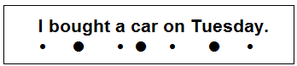
- 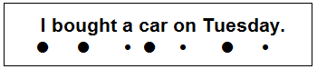
- 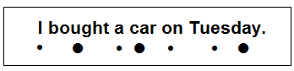
- 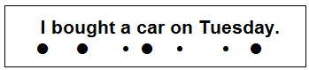

- Complete the story.

Chimaera – A fire-breathing monster
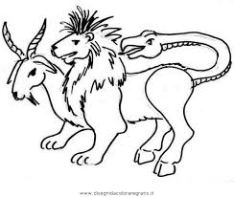

Chimaera has become one of the most famous female ______ described in Greek mythology.
Like many mythological creatures, Chimaera displayed the features of several ______ animals. Early Greek writers believed she ______ the head of a fire-breathing lion. A goat’s head arose from her back. Her tail ended in the head of a serpent.

- different – possessed - monsters
- monsters – different – possessed
- possessed – monsters - different

