ENGLISH EXAM – SECOND GRADE
UNIT 6 (POSTER)
STUDENT’S NAME: _______________________________________ GROUP: _______ TEACHER’S NAME: _____________________________ DATE: ___________________

SCORE:

MARK YOUR ANSWERS HERE
1
2
3
4
5
6
7
8
9
10

INSTRUCTIONS: CHOOSE THE CORRECT ANSWER.
PART 1

- Identify the parts of an instruction manual of a juicer.

- Instructions / steps
- Illustrations
- Diagram
- Components / List of parts

- W1, X3, Y2, Z4
- W3, X4, Y1, Z2
- W2, X1, Y4, Z3
- W4, X2, Y3, Z1

- A refrigerator is used for…

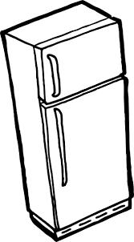

- mix, chop or liquefy foods.
- cutting paper.
- listening to music privately.
- keeping food cold.

- A blender is used to…

- listening to music privately.
- cutting paper.
- making phone calls.
- mix, chop or liquefy foods.

- You can toast bread with a…

- Juicer
- Cell phone
- Toaster
- Fan

- You can send text messages with a…

- USB memory
- Smart phone
- DVD player
- Mp3 player

- Label the verb.

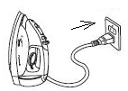

- Press down.
- Plug in.
- Turn on.
- Insert.

- Label the verb.

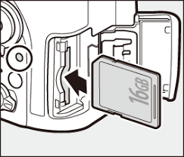

- Turn off.
- Insert.
- Unplug.
- Touch.

- Put in order the steps.

F) Put the bread into the bread holes.
G) Set the amount of toasting.
H) Wait until the toasting cycle finishes, take out the toasted bread.
I) Push down the lever to start the toasting cycle.

- H-I-F-G
- F-H-G-I
- G-F-I-H
- I-G-H-F

- Put in order the steps.

W) Set the temperature.
X) Press down the clothes with the iron.
Y) Fill the water tank with water.
Z) Turn on the clothes iron.

- Z-X-W-Y
- X-Y-Z-W
- Y-W-Z-X
- W-Z-Y-X

- Complete the comparison.

The telephone is _____ than the Galaxy V

- cheap
- cheaper
- most cheap
- the cheapest

