ENGLISH EXAM – SECOND GRADE
UNIT 4 – PART 1 (AUTOBIOGRAPHICAL ANECDOTE)
STUDENT’S NAME: _______________________________________ GROUP: _______ TEACHER’S NAME: _____________________________ DATE: ___________________

SCORE:

MARK YOUR ANSWERS HERE
1
2
3
4
5
6
7
8
9
10

INSTRUCTIONS: CHOOSE THE CORRECT ANSWER.
PART 1

- Complete the conversation.

A: Hello, Karen! How are you?
B: Hello, Susan! I’m fine.
A: Hey Karen, Where did you go yesterday?
B: I ________ to the park.
A: Really? And what did you do?
B: I ________ volleyball with my friends.
A: Was it fun?
B: Yes it ________.
A: I have class! Good bye!
B: Bye, bye!

- play - did - play
- went - played - was
- was – played - were
- go – do - fun

Read the conversation and answer the questions (2-4).

ANA:  RITA:  ANA:  RITA:  ANA:  RITA: | Did you see any movies on the weekend?  Yes, I saw “Mission to Mars”.  It wasn’t bad.  I heard about it. There are lot special effects.  Yes, the special effects were the best part.  So, did you enjoy it?  Yes, but my favorite movie is “Jurassic World”

- What movie did Rita see?

- Mission to Mars.
- Special effects.
- Jurassic World.
- The best part.

- Did Rita enjoy the movie?

- Yes, she does.
- No, she did not.
- Yes, she did.
- No, it was bad.

- When did Rita see the movie?

- On weekend.
- It wasn’t bad.
- Mission to Mars
- Yesterday

- Put in order the events.

R) Finally I took many pictures of the animals.
S) I went to the Zoo yesterday.
T) Fortunately I bought a new camera.
U) Then, I noticed I forgot my camera.

- R-T-S-U
- R-S-U-T
- S-U-T-R
- U-S-T-R

- Complete the anecdote.

Omar Eduardo Rivera is a blind computer technician who uses a guide dog.
On September 11, 2001, Rivera was working on the 71st floor of the World Trade Center when a plane ______ the building above him.

Rivera smelled the smoke and heard the chaos. He took the Labrador retriever's leash off, so the dog could escape.

The dog ______ Rivera's order to go ahead, and escorted his master down.
They reached the ground, only a few minutes before the building collapsed.
The dog ________ Rivera’s life.

a) hit – ignored - saved
b) saved – hit - ignored
c) ignored – saved - hit

- Complete the anecdote.
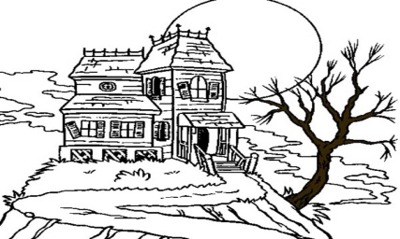

It ____ 12:30 on Friday night and I was in bed. I was tired, but I ____ asleep.

My parents ____ at home. I was alone in the house for the first time. It was very dark and quiet, but I wasn’t afraid.

- was – wasn’t – weren’t
- were – weren’t – was
- wasn’t – was – were
- weren’t – were – wasn’t

- What did you buy in the supermarket?
I _________ bread and some milk.

- buy
- put
- bought
- buyed

- Where did you go last night?

- I went to the park.
- With Katherine.
- I was very hungry.
- My favorite restaurant is nice.

- Where were you yesterday?

- You were in the school.
- I was in the hospital.
- She went to the downtown.
- I’m with you.

