ENGLISH EXAM – THIRD GRADE
UNIT 3 (SET OF INSTRUCTIONS ALBUM)
STUDENT’S NAME: _______________________________________ GROUP: _______ TEACHER’S NAME: _____________________________ DATE: ___________________

SCORE:

MARK YOUR ANSWERS HERE
1
2
3
4
5
6
7
8
9
10

INSTRUCTIONS: CHOOSE THE CORRECT ANSWER.
PART 1

- Identify the MATERIALS for experiment.
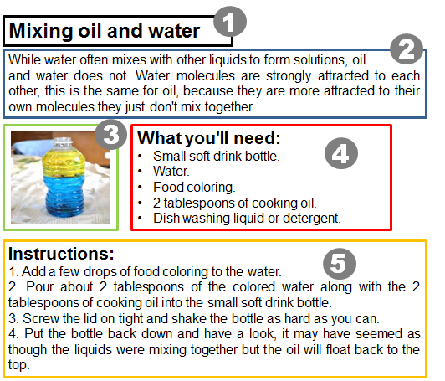
- Section 2
- Section 5
- Section 3
- Section 4

- Identify the STEPS of the experiment.

- Section 1
- Section 4
- Section 3
- Section 5

- Choose the correct option in order describe the illustration.

- Hold the glass.
- Fill the glass with water.
- Mix water and salt.
- Squeeze some lemons.

- Choose the correct option in order describe the illustration.

- Fill the cup with water.
- Squeeze the lemon.
- Stir the mixture with spoon.
- Wash the glass.

- Complete the instruction.

“______ the ingredients with a spoon”

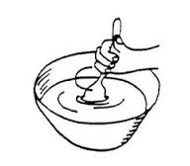

- Hold
- Cut
- Mix
- Pout

- Complete the instruction.

“______ the straw”

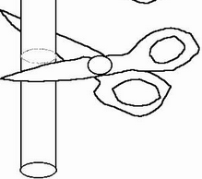

- Put
- Shake
- Watch
- Cut

- Put in order the instructions.

Experiment: “Vinegar Volcano”
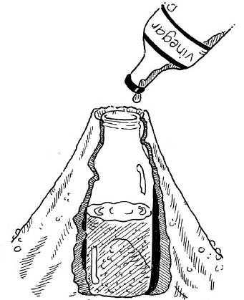

G. Next pour in some of the vinegar.
H. First place baking soda into your container.
I. Finally watch how the reaction takes place!

- H, G, I
- G, I, H
- H, I, G
- I, H, G

- Put in order the instructions.
Experiment: “Make an egg float”

Q. Fill the glass with water.
R. Lower the egg into the salt water
S. Stir 6 tablespoons of salt in the glass.
T. Watch what happens.

- T, S, Q, R
- Q, S, R, T
- Q, T, S, R
- T, R, Q, S

- Fill in the blanks.

Blowing up balloons with CO₂
(Baking soda + lemon juice)

Pour the 40 ml of water into the 1) ______.
Add the teaspoon of 2) ______ and stir it around with the straw until it has dissolved.
Pour the lemon 3) ______ in and quickly put the stretched balloon over the mouth of the bottle.

- 1-juice 2-bottle 3-baking soda
- 1-bottle 2-baking soda 3-juice
- 1-juice 2-baking soda 3-bottle
- 1-bottle 2-juice 3 baking soda

- Choose the correct instruction. Look at the illustration.

- Add two food coloring of drops.
- Add drops two food of coloring.
- Add two drops of food coloring.
- Add drops of two coloring food.

