ENGLISH EXAM – THIRD GRADE
UNIT 3 – PART 2 (REPORT ANTHOLOGY)
STUDENT’S NAME: _______________________________________ GROUP: _______ TEACHER’S NAME: _____________________________ DATE: ___________________

SCORE:

MARK YOUR ANSWERS HERE
1
2
3
4
5
6
7
8

INSTRUCTIONS: CHOOSE THE CORRECT ANSWER.
PART 2

- Identify the PARTS of the following historical texts.

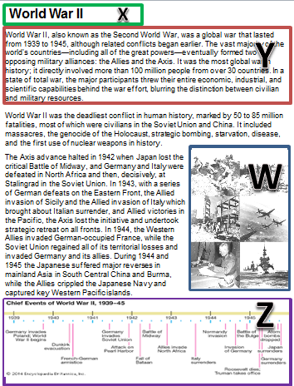

- Timeline
- Title
- Introduction
- Pictures / Illustrations

- X1, Y2, W3, Z4
- X2, Y3, W4, Z1
- X3, Y1, W2, Z4
- X1, Y3, W4, Z2

- Read the text and find the MAIN IDEA.

The Spanish were among the first Europeans to explore the New World. At the same time, people from other European nations such as England, France and Sweden began to claim land, too. | 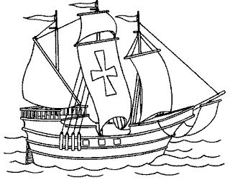

- Countries that colonized the New World.
- The Spanish were the first explorers.
- England was an important nation in the 15th century.
- The nations and how they lived.

- All the sentences describe the same historical event except one, because it is the TOPIC. Which one is it?

- The countries of the Axis were: Germany, Italy and Japan.
- World War II.
- The war was fought between 2 major alliances: the Axis (Hitler’s coalition) and the Allies.
- United States belonged to the Allies side.

- Read the text and find the SECONDARY IDEA.

The Romans invaded Great Britain and it became part of the Roman Empire. They introduced new developments in agriculture, urbanization, industry and architecture.

Main idea The Romans invaded Great Britain and it became part of the Roman Empire.
Secondary idea ?

- The invaders were the Romans.
- The conquerors introduced new and important developments.
- Great Britain was conquered by Romans.
- Only the agriculture was important for the citizens.

- Complete the historical event.

Spanish conquest of the Aztec Empire
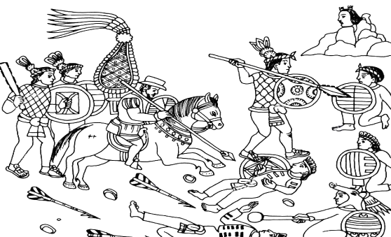

The Spanish arrived Yucatán _____. Two years later the Spanish set sail, thus beginning the campaign of colonization of the Americas. The Spanish campaign declared _______ on August 13, 1521, when a coalition army of Spanish forces and native Tlaxcalan warriors led by Hernán Cortés and Xicotencatl the Younger captured the emperor Cuauhtémoc and Tenochtitlan, the capital of the ______ Empire.

- victorious – in 1917 – Aztec
- in 1917 – Aztec - victorious
- victorious – Aztec – in 1917
- in 1917 – victorious – Aztec

- Choose the correct CONNECTOR to join the 2 ideas about the character.

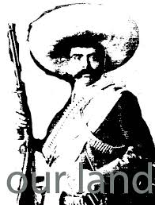
Emiliano Zapata was one of the leading figures in the Mexican Revolution _____ is now considered one of the national heroes of Mexico.

- if
- and
- but
- so
- What is the missing historical event in the timeline?

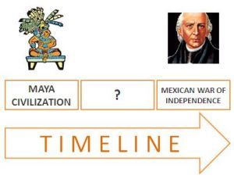
- Mexican revolution
- Dinosaurs’ extinction
- Miguel Hidalgo died.
- Spanish conquest of the Aztec Empire.

- What is the next historical event in the timeline?
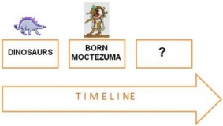
- The pyramids of Egypt.
- Columbus discovered America.
- Bronze age in China.
- The Roman Empire.

