ENGLISH EXAM – THIRD GRADE
UNIT 4 (TV PROGRAMS)
STUDENT’S NAME: _______________________________________ GROUP: _______ TEACHER’S NAME: _____________________________ DATE: ___________________

SCORE:

MARK YOUR ANSWERS HERE
1
2
3
4
5
6
7
8
9
10

INSTRUCTIONS: CHOOSE THE CORRECT ANSWER.
- The genre of the TV program “The Simpsons” is…

- reality.
- anime.
- cartoon.
- soap opera.
- Housewives with kids usually watch...

- National Geographic & ECO news.
- ESPN & The walking dead.
- Two and half men, CSI Miami & Law and Order.
- Dora the explorer & Master Chef.

- In a cultural TV program, which people talk about the huge amount of unwanted dog and cats, you probably feel…

- excited.
- hungry and thirsty.
- very sad.

- How do you feel after you watched Sponge Bob Square pants?

- I feel really good. It’s funny.
- It’s for kids aged 4 to 11.
- I watch it every day with my friends.
- In my opinion that’s very funny and amazing.

READ THE TV PROGRAM DESCRIPTION AND ANSWER THE QUESTIONS.
TV GUIDE  Cultural channel | Learn about a problem that many people underestimate – thousands of pets without homes or people to love them. Hear from vets, shelter workers, and other people who are involved in trying to educate the public about the responsibilities of having pets. Find out how you can help.

- What is the main idea of the show?

- That my little puppy is in danger.
- That some people try to help animals.
- That there are too many unwanted animals.

- What is the purpose of this type of show?

- To entertain people.
- To make people aware of a problem.
- To kill the unwanted dogs and cats.
- To make people feel very sad.

- Which one is NOT a type of TV show?

- Documentary
- Soap opera
- Letter
- Sports

- Look at the image and identify the feeling or emotion.
- happy
- sad
- furious
- scared

- The “UEFA Champions League” is…
- soap opera
- anime.
- cartoon.
- sport.

- “Lo que la vida me robo” is a…
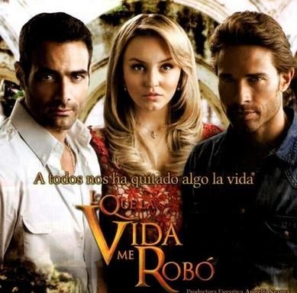
- soap opera.
- sport program.
- cartoon.
- cultural program.

