ENGLISH EXAM – THIRD GRADE
UNIT 5 (MEMORY GAME)
STUDENT’S NAME: _______________________________________ GROUP: _______ TEACHER’S NAME: _____________________________ DATE: ___________________

SCORE:

MARK YOUR ANSWERS HERE
1
2
3
4
5
6

INSTRUCTIONS: CHOOSE THE CORRECT ANSWER.
PART 1

- Match the games with the images.

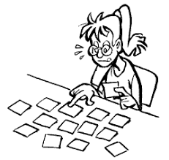
X | Y | Z

- Bingo
- Lottery
- Memory game
- Scrabble

- X1, Y2, Z4
- X2, Y4, Z1
- X2, Y1, Z3
- X3, Y2, Z1

- Which verb is irregular?

- play
- like
- go
- love
- Read the text and find the irregular verb.

People played on a square board that had horizontal and vertical lines that crisscrossed.

- played
- had
- that
- crisscrossed

- Which sentence has a regular verb?

- She will go to the park.
- She ate a lot of food yesterday.
- She cooks very well.
- She has gone away.

- Classify the sentences in tenses.

X. Have you ever eaten sushi?
Y. They went to the supermarket yesterday.
Z. He runs every day in the morning.

1. Past tense.
2. Present perfect tense.
3. Past perfect tense.
4. Present tense.

- X1, Y3, Z4
- X2, Y1, Z4
- X3, Y2, Z1
- X2, Y1, Z3

- Complete the sentences.

She didn’t ___ well last night.
We have ___ at that restaurant many times.
They ___ exercise regularly.

- sleeps, eat, did
- slept, ate, done
- sleep, eaten, do
- has sleep, didn’t eat, have done

