ENGLISH EXAM
UNIT 4 (SCRIPT)
STUDENT’S NAME: _______________________________________ GROUP: _______ TEACHER’S NAME: _____________________________ DATE: ___________________

SCORE:

MARK YOUR ANSWERS HERE
1
2
3
4
5
6

INSTRUCTIONS: CHOOSE THE CORRECT ANSWER.
- Look at the image of the silent film scene and choose the correct intention of that action.

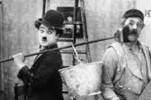

- Melodramatic
- Romance
- Funny

2. Describe the image.

- He walks on the street
- He receives a letter
- He throws a stone

3. Match the action with the picture.
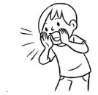
- He eats bananas
- He plays soccer
- He asks for help!

4. Identify the parts of a script.
DOCTOR
- We did everything possible.
CATHY
(gasp)
What are you saying?
- DOCTOR
I’m sorry
CATHY
- (screaming)
No!!!
- 1-Dialogues / 2- Character name / 3- Emotions
- 1-Emotions / 2- Parenthetical / 3- Character name
- 1-Beginning / 2- Middle / 3- End

5. Read the following script and choose the correct dialogue to complete the scene.
MOLLY
Guess what? SUSAN. I went to Miami last summer.
SUSAN
(excited)
?
- What color is the dress?
- Oh really! It’s fantastic. Who did you travel with?
- Once upon a time there was an ugly witch.

