TRABAJO DE REGULARIZACIÓN Y GUÍA DE ESTUDIO PARA EL EXAMEN

PARA ALUMNOS DE PRIMERO QUE REPROBARÓN LA UNIDAD 2

NOMBRE DEL ALUMNO(A): ___________________________________________ GRUPO: “___”

|  |
| --- |
| Review Verb To be |

Affirmative

I **am** a girl

You **are** Mexican.

He / She / It **is**

We **are** friends

You **are** happy

They **are** from Paris

Complete the sentences with the affirmative form of the verb. Write long forms (am, is, are).

|  |  |
| --- | --- |
| 1. Stephen __**i s**___ very intelligent. 2. My books _______ on the shelf. 3. I _______ hungry now. 4. This coffee _______ cold. | 1. Tigers _______ orange and black. 2. My house _______ very small. 3. They _______ from Japan. 4. I _______ a good student. |

Put the words in order.

1) my sister / She / is __ .

2) black / My cat / is __ .

3) My mother / beautiful / is __ .

4) is / It / an apple __ .

5) friends / are / We / good __ .

|  |
| --- |
| Possessive Adjectives |

|  |  |  |  |  |  |
| --- | --- | --- | --- | --- | --- |
| I | my  mi(s) |  | | | |
| 1. __My___ name is John.  2. This is ____ book.  3. ____ jeans are blue. | **__Mi nombre es John_______________**  **__________________________________**  **__________________________________** | | |
| You | your  tu(s) | 1. That is __your___ notebook. **_Esa es tu libreta_________________**  2. It’s _______ birthday. **__________________________________**  3. Susan and Maggie are _______ friends.  **__________________________________** | | | |
| He | his  su(s) [de él] |  | | | |
| 1. _____ brother is 7 years old.  2. These are ____ books.  3. They are ______ parents. | | **_____________________________**  **_____________________________**  **_____________________________** | |
| She | her  su(s) [de ella] |  | | | |
| 1. Rocky is _____ dog.  2. That’s ______ house.  3. ______ skirt is red and blue. | | | **_____________________________**  **_____________________________**  **_____________________________** |

|  |
| --- |
| Part of speech – Review |

Complete the table.

|  |  |  |  |
| --- | --- | --- | --- |
| **Entry word** | **Image** | **Part of speech**  **(Noun/Verb/Pronoun/Adjective)** | **Translation into Spanish** |
| 1. Eat |  | _____________verb______________ | _____________comer_____________ |
| 2. Pen |  | ______________________________ | ______________________________ |
| 3. Big |  | ______________________________ | ______________________________ |
| 4. Circus |  | ______________________________ | ______________________________ |
| 5. They |  | ______________________________ | ______________________________ |
| 6. She |  | ______________________________ | ______________________________ |
| 7. Drink |  | ______________________________ | ______________________________ |
| 8. Rabbit |  | ______________________________ | ______________________________ |

|  |
| --- |
| Dictionary components |

Label the dictionary components. Use the words from the box.

|  |
| --- |
| meaning of the word – entry word – pronunciation –  abbreviation/part of speech – example sentence |

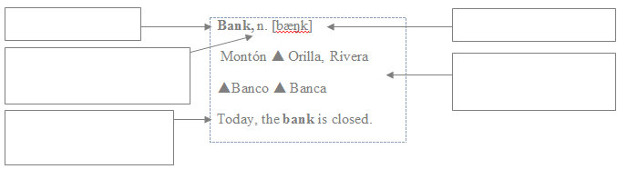

Complete the table of abbreviations.

|  |  |
| --- | --- |
| Abbreviation / Part of speech | Meaning |
| 1. adj | adjective |
| 2. n |  |
| 3. v. |  |
| 4. pron. |  |

Parts of a dictionary entry

Work in pairs and complete the following dictionary entry with the words from the box. Use your dictionary.

|  |
| --- |
| An ant is an insect. - Ant – [ænt] – n. – Hormiga – noun |

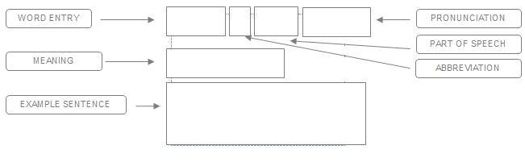

|  |
| --- |
| Abbreviations |

Match the abbreviations with the meanings.

|  |  |  |  |
| --- | --- | --- | --- |
| 1. Abbr. 2. Adj. 3. Adv. 4. AmE. 5. BrE. 6. C. 7. Conj. 8. Det. | 1. _____ Adjective 2. _____ American English 3. _____ Countable Noun 4. _____ Determiner 5. _____ Conjunction 6. _____ British English 7. _____ Adverb 8. _____ Abbreviation | 1. Pl. 2. Pron. 3. Pt. 4. Sing. 5. Sth. 6. U. 7. N. 8. Prep. 9. Adv. | 1. _____ adverb 2. _____ preposition 3. _____ noun 4. _____ uncountable 5. _____ something 6. _____ singular 7. _____ past tense 8. _____ pronoun 9. _____ plural |

|  |
| --- |
| Types of radio programs |

Match the adjectives with the events in a TV show.

|  |
| --- |
| news – sports – entertainment – music – gaming – weather – documentary |

|  |  |  |  |
| --- | --- | --- | --- |
|  |  | http://us.123rf.com/450wm/seamartini/seamartini1304/seamartini130400045/19089931-el-arte-abstracto-de-fondo-la-musica-con-las-notas-musicales-para-el-diseno-de-entretenimiento.jpg | http://thumbs.dreamstime.com/z/el-vector-de-la-estrella-del-zodiaco-firma-2-18152469.jpg |
| ___________________ | _____________________ | _______________________ | ________________________ |

|  |  |  |
| --- | --- | --- |
| http://st-listas.20minutos.es/images/2011-02/274462/2871348_640px.jpg?1297449281 |  | http://www.hacesfalta.org/IO/Blogs/FotosPosts/2515b5823434-1a00-48d9-b597-a88896198c0b.jpg |
| ___________________ | _____________________ | _______________________ |

|  |
| --- |
| Giving opinion about radio programs |

We use adjectives to express positive or negative opinions. Put the following adjectives in the correct category.

|  |
| --- |
| awesome - terrible – funny – fantastic - cool – horrible - excellent – amazing – boring |

|  |  |  |
| --- | --- | --- |
| Positive 🗸 |  | Negative 🗴 |
|  |  |  |

Translate the expressions into Spanish.

|  |  |
| --- | --- |
| **How to express opinions** | |
| **In my opinion** |  |
| **I think that** |  |
| **According to (person)** |  |

Write 3 sentences expressing opinions.

1. _______________________________________________________________________
2. _______________________________________________________________________
3. _______________________________________________________________________

GUÍA DE ESTUDIO PARA EL EXAMEN DE PRIMEROS – UNIDAD 2

**PART 1**

1. Some of types of dictionaries are:

1. Stories, Novel and Fable.
2. Monolingual, Bilingual and Pictionary.
3. Bible and Journals.
4. Magazine and Newspaper.

**IDENTIFY THE DICTIONARY COMPONENTS.**

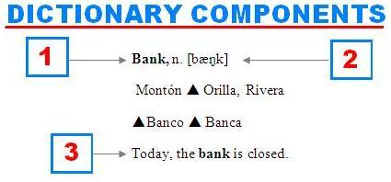

1. 1-Headword / 2-Part of speech / Translation
2. 1-Bank / 2-Pronunciation / 3-Statement
3. 1-Entry word/2-Pronunciation/3-Example sentence
4. 1-Noun / 2-Part of speech / 3-Full sentence

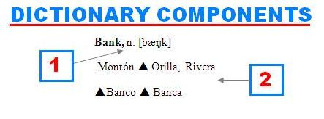

1. 1-Noun / 2-Example sentence
2. 1-Part of speech / 2-Translation
3. 1-Pronunciation / 2-Spanish version
4. 1-Verb / 2- Nouns

4. The word “write” is…

1. a pronoun
2. a noun
3. an adjective
4. a preposition.

5. The word “beautiful” is…

1. a pronoun
2. a noun
3. an adjective
4. a preposition.

6. **COMPLETE THE TABLE WITH THE MEANING.**

|  |  |
| --- | --- |
| **Abbreviation** | **Meaning** |
| 1. Adj |  |
| 2. n |  |
| 3. v. |  |
| 4. pron. |  |

1. abjective – noon – verb – proname
2. adjetive – nuon – verb – prooun
3. adjective – noun – verb – pronoun
4. adjetive – nooun – verb - pronomb

**PART 2**

**ANSWER THE QUESTIONS.**

7. What expressions do we use to express positive opinions?

1. Not interesting, not like, boring, too formal
2. Hello, good bye, see you!
3. Listen to, write, watch
4. Interesting, fun, awesome, cool

8. Which opinion is a negative opinion?

1. The program was very interesting.
2. It was boring because there was no music.
3. I love this radio program.
4. I like the music programs.

9. Mark loves listening to 96.5 F.M. but ____________ it’s terrible!

1. according to
2. think
3. in my opinion
4. listen

10. Label the parts of the radio program

|  |  |  |
| --- | --- | --- |
| **1** | **2** | **3** |
| Pop hits | 89.2 | Music |

1. 1- Name of the program / 2- Type / 3-Station
2. 3- Name of the program / 1- Type of Program / 2- Station
3. 1- Name of the program / 3. Type of Program 2. Station
4. 2- Name / 1- Type of Program / 3- Station