TRABAJO DE REGULARIZACIÓN Y GUÍA DE ESTUDIO PARA EL EXAMEN

PARA ALUMNOS DE PRIMERO QUE REPROBARÓN LA UNIDAD 3

NOMBRE DEL ALUMNO(A): ___________________________________________ GRUPO: “___”

|  |
| --- |
| Jobs and occupations |

Match the occupations with the pictures.

|  |
| --- |
| Psychologist – Singer - Engineer – Nurse - Businessman/woman |

|  |  |  |  |  |
| --- | --- | --- | --- | --- |
|  |  |  |  |  |
| ________________ | ________________ | _______________ | ________________ | ________________ |

|  |
| --- |
| Hair stylist – Mechanic – Secretary – Housewife - Actress |

|  |  |  |  |  |
| --- | --- | --- | --- | --- |
|  |  |  |  |  |
| ________________ | ________________ | _______________ | ________________ | ________________ |

|  |
| --- |
| Jobs and occupations 2 |

Write about your future life. Look at the example.

Example:

|  |  |
| --- | --- |
|  | My name is Sarah Jones  1. She **will** work as a singer.  2. She **will** get married in 2030  3. She **will** have 4 babies.  4. She **will** travel to London in 2045. |

|  |  |
| --- | --- |
|  | My name is __________________ ______________________  1. I **will** w o r k as a _____________________________  2. I **will** g e t m a _ _ _ _ _ in 2 0 _ _  3. I **will** h _ _ _ ___ babies.  4. I **will** travel to ______________ in 2 0 _ _ . |

Predictions or future plans

Are these sentences predictions or future plans?

|  |  |
| --- | --- |
| 1. She **will** drink that soda. | _____P r e d i c t i o n______________ |
| 2. I am **going** to meet a new friend tomorrow morning. | _____F u t u r e p l a n _____________ |
| 3. We are **going** to Mexico City next weekend. | _________________________________ |
| 4. She’s **going** to play soccer in the afternoon. | _________________________________ |
| 5. I**’ll** graduate from University in 2024. | _________________________________ |
| 6. I **won’t** get married in December. | _________________________________ |
| 7. **Will** you dance with me tonight? Yes, I will. | _________________________________ |
| 8. Are you **going** to buy a new Xbox One S? Yes, I am. | _________________________________ |

My future

Now, tell me about your future.

|  |  |
| --- | --- |
|  | **My future**   1. What is your name? _______________ _________________ 2. How old are you? I’m _____ years old. 3. In the future, I will ________________________________________ 4. In 3 years, I will __________________________________________ 5. In 5 years, I will __________________________________________ 6. In 10 years, I ________ ______________________________________ |

Internal organs

|  |
| --- |
| kidney- heart - right kidney – liver - spinal cord - small intestine  stomach - large intestine – brain - right kidney –  left lung – bladder - left kidney |



Digestive system

Translate the parts of the body and find them in the word soup in English.

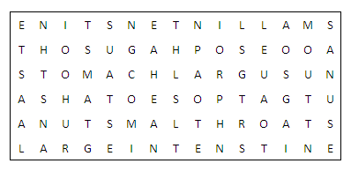

|  |  |  |  |
| --- | --- | --- | --- |
| 1. BOCA | M _ _ _ _ | 5. INTESTINO DELGADO | S _ _ _ _ - I _ _ _ _ _ _ _ _ |
| 2. GARGANTA | T _ _ _ _ _ | 6. INSTESTINO GRUESO | L _ _ _ _ - I _ _ _ _ _ _ _ _ |
| 3. ESOFAGO | E _ _ _ _ _ _ _ _ | 7. ANO | A _ _ _ |
| 4.ESTOMAGO | S _ _ _ _ _ _ |  |  |

Label the parts of the body system.

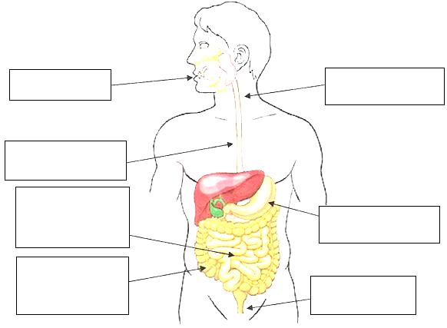

|  |
| --- |
| Body parts |

Classify the following organs according to the system they belong to. Translate each word.

|  |
| --- |
| lungs - heart – brain – stomach - ~~veins~~ – nose – intestines – ~~skull~~ – ~~biceps~~ – vertebral column – ~~mouth~~ – ~~trachea~~ – arteries – spinal cord – triceps  esophagus – bronchus – blood – nerves – ribs - abs |

|  |
| --- |
| **Digestive System** |
| ____Mouth____ _____________ ____________ ____________  ____Boca____ _____________ ____________ ____________ |
| **Respiratory System** |
| ____________ ____Trachea___ _____________ ____________  ____________ ____Traquea___ _____________ ____________ |
| **Nervous System** |
| _____________ _________________________ ____________  _____________ ______Medula espinal_______ ____________ |
| **Muscular System** |
| ____Biceps___ ____________ ____________  ____Biceps___ _____________ ____________ |
| **Skeletal System** |
| ____Skull_____ ____________ ________________________  _____________ ____________ ________________________ |
| **Circulatory System** |
| _____________ _______________ _____Veins_____ ____________  ______________ _______________ ______________ ____________ |

Question words – Body systems

Complete the questions with *What*, *Where* or *How*.

1. ____________ is the function of the small intestine? It absorbs the nutrients from the food.
2. ____________ is the pancreas located? It’s on the right side of the abdomen and is connected to the duodenum
3. ____________ big is the heart? It’s roughly the size of a large fist.
4. ____________ are the arteries? The arteries are blood vessels that deliver oxygen-rich blood.

Match the questions with the answers.

|  |  |
| --- | --- |
| 1. **Where** **does** digestion **start**? 2. **What** **do** the lungs **do**? 3. **How does** the stomach **digest** food? 4. **Does** the liver filters toxins from the blood? | ( ) They send oxygen-rich blood to the left side of the heart.  ( ) Yes, it does.  ( ) It begins in the mouth when the process of chewing.  ( ) With the help of a mixture of digestive enzymes and acid. |

GUÍA DE ESTUDIO PARA EL EXAMEN DE PRIMEROS – UNIDAD 3

**PART 1**

**COMPLETE THE PREDICTIONS**

“He ___________ skate in the park”

|  |  |
| --- | --- |
|  | 1. will skate 2. is will 3. will |

“They ___________ married”

|  |  |
| --- | --- |
|  | 1. are get 2. will 3. will get |

“The family ___________ the zoo”

|  |  |
| --- | --- |
|  | 1. love elephants 2. won’t travel 3. will visit |

Mr. Flores is sick …

1. he will take medicines
2. he will drink cold drinks
3. he will not go to the doctor

I am thirsty…

1. I will buy a soda
2. I will eat a hamburger
3. I won’t drink anything

Sarah has a soccer match next Monday…

1. She will practice every day
2. He will win the cup
3. His mom will buy 2 tickets

**PART 2**

Name the body system

|  |  |
| --- | --- |
| 1. respiratory system 2. digestive system 3. circulatory system 4. skeletal system |  |

|  |  |
| --- | --- |
| 1. respiratory system 2. digestive system 3. circulatory system 4. skeletal system |  |

|  |  |
| --- | --- |
| 1. respiratory system 2. digestive system 3. circulatory system 4. nervous system |  |
| 1. respiratory system 2. digestive system 3. circulatory system 4. nervous system | Description: http://upload.wikimedia.org/wikipedia/commons/c/cb/Human_Heart_and_Circulatory_System.pngDescription: http://upload.wikimedia.org/wikipedia/commons/c/cb/Human_Heart_and_Circulatory_System.pngDescription: http://upload.wikimedia.org/wikipedia/commons/c/cb/Human_Heart_and_Circulatory_System.png |

|  |  |
| --- | --- |
| 1. respiratory system 2. digestive system 3. circulatory system 4. nervous system |  |

Name this body part.

|  |  |
| --- | --- |
| 1. Liver 2. Heart 3. Kidney |  |