TRABAJO DE REGULARIZACIÓN Y GUÍA DE ESTUDIO PARA EL EXAMEN

PARA ALUMNOS DE SEGUNDO QUE REPROBARÓN LA UNIDAD 2

NOMBRE DEL ALUMNO(A): ___________________________________________ GRUPO: “___”

|  |
| --- |
| Emergency instructions – Imperative Sentences |

**Match the instructions with the pictures.**

|  |
| --- |
| Do not use elevators - Stay calm – Do not run – Find security zones |

|  |  |  |  |  |  |
| --- | --- | --- | --- | --- | --- |
| **WHAT TO DO IN CASE OF EARTHQUAKE** | | | | | |
|  | ____________  ____________  ____________ |  | GET AWAY FROM THINGS THAT CAN ORIGINATE FIRE |  | AVOID WINDOWS AND OBJECTS THAT COULD FALL |
|  | ____________  ____________  ____________ |  | ____________  ____________  ____________ |  | ____________  ____________  ____________ |

|  |
| --- |
| Imperative sentences |

Match the instructions with the pictures.

|  |  |  |  |  |  |
| --- | --- | --- | --- | --- | --- |
| **IMPERATIVE SENTENCES** | | | | | |
| **AFFIRMATIVE** | | | **NEGATIVE** | | |
| 1. **Get away** from  objects that could fall. |  |  | 4. **Do not use**  elevators. |  |  |
| 2. **Use** mask |  |  | 5. **Do not run**. |  |  |
| 3. **Provide** first aids. |  |  | 6. **Do not drive** into flooded areas. |  |  |

Word search

**Search up, down, forward, backward, and on the diagonal to find the hidden words in English. Also, fill in the blanks.**



|  |  |  |  |
| --- | --- | --- | --- |
| 1. EMERGENCIA 2. TERREMOTO 3. INUNDACIÓN 4. DERRAME DE PETROLEO 5. HURACAN 6. EVACUAR 7. INCENCIO | E _ _ _ _ _ _ _ _  EARTH _ _ _ _ _  F _ _ _ _  O _ _ SP _ _ _  H _ _ _ _ _ _ _ _  E V A C U A _ _  FORE _ _ F _ _ _ | 8. MANTEN LA CALMA  9. AYUDAR A LOS DEMAS  10. LLAMAR AL  DOCTOR  11. DAR PRIMEROS  AUXILIOS  12. USAR MASCARA  13. LAVAR MANOS  14. MANTENERSE ALEJADO DE… | S T A _ CA _ _  H _ _ P OTHER _  C A _ _ T H _  D _ _ _ _ _  P R O V I _ _  F I R _ _ A _ _  U _ _ M _ _ _  W A S _ H A N _ _  ST _ _ A _ _ _  F _ _ _... |

|  |
| --- |
| Review Verb To be |

Affirmative

I **am** a girl

You **are** Mexican.

He / She / It **is**

We **are** friends

You **are** happy

They **are** from Paris

Complete the sentences with the affirmative form of the verb. Write long forms (am, is, are).

|  |  |
| --- | --- |
| 1. Stephen __**i s**___ very intelligent. 2. My books _______ on the shelf. 3. I _______ hungry now. 4. This coffee _______ cold. | 1. Tigers _______ orange and black. 2. My house _______ very small. 3. They _______ from Japan. 4. I _______ a good student. |

Put the words in order.

1) my sister / She / is __ .

2) black / My cat / is __ .

3) My mother / beautiful / is __ .

4) is / It / an apple __ .

5) friends / are / We / good __ .

|  |
| --- |
| Possessive Adjectives |

|  |  |  |  |  |  |
| --- | --- | --- | --- | --- | --- |
| I | my  mi(s) |  | | | |
| 1. __My___ name is John.  2. This is ____ book.  3. ____ jeans are blue. | **__Mi nombre es John_______________**  **__________________________________**  **__________________________________** | | |
| You | your  tu(s) | 1. That is __your___ notebook. **_Esa es tu libreta_________________**  2. It’s _______ birthday. **__________________________________**  3. Susan and Maggie are _______ friends.  **__________________________________** | | | |
| He | his  su(s) [de él] |  | | | |
| 1. _____ brother is 7 years old.  2. These are ____ books.  3. They are ______ parents. | | **_____________________________**  **_____________________________**  **_____________________________** | |
| She | her  su(s) [de ella] |  | | | |
| 1. Rocky is _____ dog.  2. That’s ______ house.  3. ______ skirt is red and blue. | | | **_____________________________**  **_____________________________**  **_____________________________** |

|  |
| --- |
| Script / Action lines |

Look at the pictures (movie scene) and write the scene heading for each movie scene. Look at the example.

|  |
| --- |
| * KEVIN finds a treasure map. He and her best friend rent a boat. * MARK watches T.V. His favorite team wins the league. He decides to have a big party. * SUSAN serves the turkey for the Christmas dinner. Her family is very happy and enjoys the meal. |

|  |  |
| --- | --- |
| MOVIE SCENE | SCENE HEADING AND ACTION |
|  | EXT. CAFÉ – MORNING  SUSAN and MOLLY buy some coffee and start walking to SUSAN’s house. MOLLY talks about her last vacation. |
|  | INT. JOHN’S HOUSE – CHRISTMAS NIGHT  ______________________________________________________  ______________________________________________________ |
|  | INT. LIVING ROOM - AFTERNOON  ______________________________________________________  ______________________________________________________ |
|  | EXT. BEACH - MORNING  ______________________________________________________  ______________________________________________________ |

|  |
| --- |
| Script / Action lines |

Fill in the blanks in order to complete the script.

|  |
| --- |
| PETE - captain – kicks - happy |

|  |  |
| --- | --- |
| MOVIE SCENE | SCENE HEADING AND ACTION |
|  | INT. STEAMBOAT - MORNING  MICKEY MOUSE pilots a river steamboat, suggesting that he himself is the __________. He cheerfully whistles "Steamboat Bill" and sounds the boat's three whistles.  MICKEY MOUSE  (________)  It's a beautiful day!  The real captain appears (PETE) and angrily orders MICKEY off the bridge.  ______  (angry)  What are you doing?  PETE attempts to kick him but MICKEY rushes away in time and PETE _____________ himself in the rear accidentally. |

GUÍA DE ESTUDIO PARA EL EXAMEN DE SEGUNDOS – UNIDAD 2

Look at the emergency sign and choose its meaning.

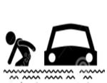

1. Abandon your vehicle
2. Run
3. Drive your car

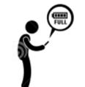

1. Call your mommy
2. Chech phone batteries
3. Stay calm

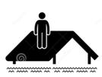

1. No climbing
2. Do not climb
3. Climb to the roof

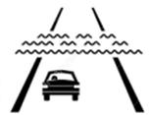

1. Drive very fast
2. Do not evacuate
3. Do not drive into flooded areas

**CHOOSE THE RIGHT OPTION IN ORDER TO COMPLETE THE INSTRUCTION TO FACE A TSUNAMI EVENT.**

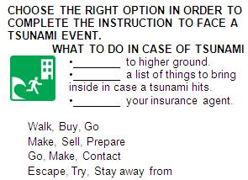

1. Walk, Buy, Go
2. Make, Sell, Prepare
3. Go, Make, Contact
4. Escape, Try, Stay away from

WHAT TO DO IN CASE OF EARTHQUAKE

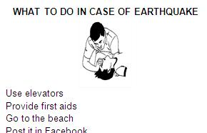

1. Use elevators
2. Provide first aids
3. Go to the beach
4. Post it in Facebook

**PART 2**

**Look at the image and identify the parts of the script.**

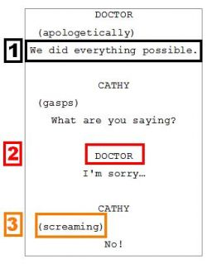

 1-Emotions / 2- Directions / 3- Character name

 1-Scene heading / 2- Emotions / 3- Action lines

 1-Dialogues / 2- Character name / 3- Parenthetical

 1-Beginning / 2- Middle / 3- End

**Read the following script and choose the most appropriate dialogue to complete the scene.**

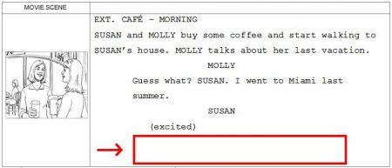

 Oh really! It’s fantastic. Who did you travel with?

 I love my new shoes.

 What color is the sky?

 Once upon a time there was a beautiful princess.