TRABAJO DE REGULARIZACIÓN Y GUÍA DE ESTUDIO PARA EL EXAMEN

PARA ALUMNOS DE SEGUNDO QUE REPROBARÓN LA UNIDAD 3

NOMBRE DEL ALUMNO(A): ___________________________________________ GRUPO: “___”

|  |
| --- |
| The alphabet |

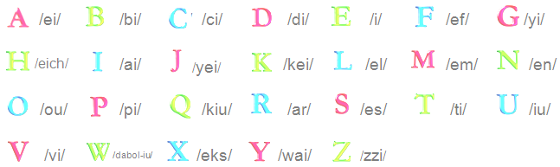

Write how you pronounce each letter.

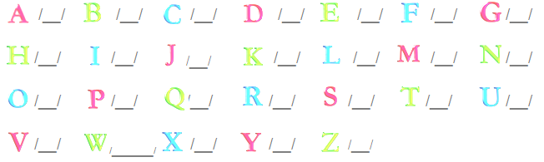

Write how you spell the words, letter by letter.

|  |  |
| --- | --- |
| 1. house 2. drink 3. radio 4. zebra 5. print | eich – ou – iu – es - i  _______________________________  _______________________________  _______________________________  _______________________________ |

|  |  |
| --- | --- |
| Crossword – Past tense (Irregular verbs) |  |
| Fill in the correct answers, one letter per square, both across and down from the given clues. | **ACROSS**  2. The athlete _ _ _ 20 kilometers last Friday.  3. She _ _ _ _ in the swimming pool yesterday.  5. They _ _ _ _ _ _ a new pair of jeans.  6. My sister _ _ _ _ _ a letter for her boyfriend.  8. He _ _ _ tacos last Sunday.  9. My brother _ _ _ the cats last weekend. |
| **DOWN**  1. My mom _ _ _ _ _ cappuccino yesterday.  3. She _ _ _ _ _ in her mother's bed last night.  4. The children _ _ _ _ _ the new lamp yesterday.  7. The students _ _ _ _ a book yesterday. |

|  |
| --- |
| Pictionary – Adjectives to compare devices / machines |

Match the adjectives with the pictures.

|  |
| --- |
| fast - cheap – the best – interesting – expensive – big – the worst – small |

|  |  |  |  |
| --- | --- | --- | --- |
|  |  |  |  |
| ________________________ | _________________________ | __________________________ | __________________________ |
|  |  |  |  |
| ________________________ | _________________________ | __________________________ | ___________________________ |

|  |
| --- |
| Comparisons |

**Complete the tables.**

|  |  |  |  |
| --- | --- | --- | --- |
| **Adjective** | **Spanish** | **Comparative adjective** | **Spanish** |
| big | g r a n d e | bigg**er** (than) | **m á s** g r a n d e (que) |
| small | p e q u e ñ o | small**er** (than) | **m á s**  p e q u e ñ o (que) |
| nice |  | nic**er** (than) |  |
| cheap |  | cheap**er** (than) |  |
| fast |  | fast**er** (than) |  |
| expensive |  | **more** expensive |  |

|  |  |  |  |
| --- | --- | --- | --- |
| **Adjective** | **Spanish** | **Superlative adjective** | **Spanish** |
| big | g r a n d e | the biggest | **el m á s** g r a n d e |
| small |  | the smallest |  |
| good |  | the best |  |
| bad |  | the worst |  |

|  |
| --- |
| Modal verb - Can |

Match the devices with their use.

|  |  |  |
| --- | --- | --- |
| Licuadora.jpg |  | You **can** mix food. |
| **descarga.jpg** |  | You **can** send e-mails. |
| images.png |  | You **can** keep the food cold. |
| descarga (2).jpg |  | You **can** remove wrinkles from the clothes. |

Fill in the blanks with the words from the box.

|  |
| --- |
| cell phone - toast – heat – can (x2) – play |

1. You can ________________ the food very quickly with the microwave oven.
2. You _____________ watch DVDs with the DVD ´player.
3. You can ________________ bread with a toaster.
4. You can make call with a ____________________.
5. You __________ ________________ “Plants vs Zombies 2” with a tablet.

|  |
| --- |
| What is a microwave? |

Complete the sentences using the comparative and superlative adjectives from the box.

|  |
| --- |
| worst - ~~practical~~ – best – cheaper – expensive – higher – faster - slower |

|  |  |  |
| --- | --- | --- |
|  | 🡨 1. A Microwave ovens heats food more ___practical_____ than a flame.  2. Microwaves cook and heat _________________ than traditional ovens. 🡪 |  |
| *Popcorns* | 🡨 3. The _________________ option to make popcorns is by the microwave oven.  4. A microwave oven is ________________ than a stove. 🡪 |  |
|  | 🡨 5. Exposure to ________________ wattage can affect a human’s health. |  |

Now compare a telephone with a cellphone. You can use the following adjectives:

|  |
| --- |
| cheaper – expensive – smaller – bigger - nicer – more practical – nicest – faster – more beautiful |

|  |  |  |
| --- | --- | --- |
|  | 1. The telephone is _________________ than the cellphone. 2. _____ _______________ _____ _______________ ____________ ______ ______________ 3. ______________________________________________________________________________ |  |

GUÍA DE ESTUDIO PARA EL EXAMEN DE SEGUNDOS – UNIDAD 3

**PART 1**

Write the missing letter. Look at the image.

|  |  |
| --- | --- |
|  | **FRUITS**  A _ _ L E AND _INEA_ _LE |

_____

|  |  |
| --- | --- |
|  | **ADJECTIVES**  BE_UTIFUL _ND SM_LL |

_____

**PART 2**

Match the image with the instruction.

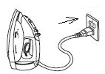

1. Unplug
2. Turn off
3. Plug in

**COMPLETE THE COMPARISON**

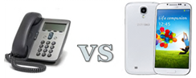

The telephone is _____ than the Galaxy V

1. cheap
2. cheaper
3. most cheap

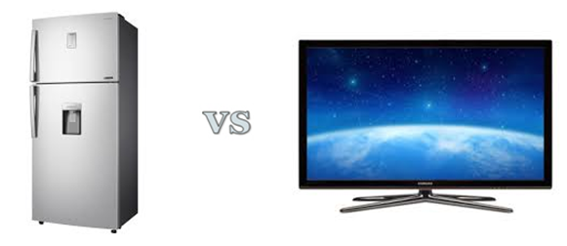

The television is smaller _____ the fridge.

1. than
2. that
3. this

Put in order the steps

F) Put the bread into the bread holes.

G) Set the amount of toasting.

H) Wait until the toasting cycle finishes, take out the toasted bread.

I) Push down the lever to start the toasting cycle.

1. H-I-F-G
2. F-H-G-I
3. G-F-I-H

Match the meaning of the phrasal verbs:

|  |  |
| --- | --- |
| Turn on | Make something work |
| Light up |

|  |  |
| --- | --- |
| Put in | Move to a specific position |
| Remove |

|  |  |
| --- | --- |
| Plug in | Take out |
| Connect |

|  |  |
| --- | --- |
| Turn off | Take out |
| Stop working |

A refrigerator is used for…

1. mix, chop or liquefy foods.
2. cutting paper.
3. listening to music privately.
4. keeping food cold

A blender is used to…

1. listening to music privately.
2. cutting paper.
3. making calls.
4. mix, chop or liquefy foods.