TRABAJO DE REGULARIZACIÓN Y GUÍA DE ESTUDIO PARA EL EXAMEN
PARA ALUMNOS DE SEGUNDO QUE REPROBARÓN LA UNIDAD 4

NOMBRE DEL ALUMNO(A): ___________________________________________ GRUPO: “___”

Setting the scene 1 - Anecdote

Answer the questions with the correct description of a setting. Use the statements from the box. Look at the examples.

- When I was a child…  - It was raining very heavily that night…  - This story took place in my neighborhood…  - This happened to me when I was 10 years old…  - I’ll never forget my first love. | - My mother and I visited my grandmother’s house.  - It was a bright and sunny saturday afternoon.  - The last vacation, me and my family…  - This story is about a boy who lived next door.

Where did the story take place? | __I was eating at home when…______________________  ________________________________________________  ________________________________________________
When did the story happen? | __This story took place in 2013…_____________________  ________________________________________________  ________________________________________________  ________________________________________________
What's the weather or climate like? | __It was very cold outside…_________________________  ________________________________________________  ________________________________________________
What special details make it clear to understand? | __It was the first time…_____________________________  ________________________________________________  ________________________________________________

Was Were - Anecdotes

Fill in the blanks with WAS or WERE.

The last vacation, me and my friends went to Manzanillo. It ________ my favorite vacation, we ________ two women and two men so that ________ kind of romantic too.
We stayed at a small hotel. The person who received us when we just arrived there ________ an old man. He ________ nice and really kind.

The first day we ________ there, we went to visit a little beach that ________ like 20 minutes away from town. There ________ a little swamp with a few crocodiles. I ________ really surprised. After that, we took a walk around the beach and watched the beautiful sunset. I'll never forget that moment, it ________ one of the most special times I've had in my life. I hope some day I can repeat some vacations like those. They ________ unforgettable.

Adverbs of time – Past tense

Underline the adverb of time in each sentece.

1. I saw my boyfriend last week.
2. His grandmother died two years ago.
3. What did you do yesterday?
4. She came here the day before yesterday.
Fill in the blanks.
yesterday – summer – ago – last - years

1. I didn’t play video games with my friend Carl ______________.
2. The last ______________, I went to the beach with my family.
3. This happened a long time ______________, I think when I was eleven years old.
4. We talked for hours on the phone ______________ night.
5. It happened several ______________ ago in my birthday party.

Sequence words – Anecdotes

Put in order the events of the anecdote (1-6).

( ) After that, my mom confiscated their guns.
( 1 ) One day I went into my bedroom and didn’t find my beautiful doll.
( ) Then, I looked for her everywhere, but I couldn’t find her.
( ) Next I started crying, and inmmediately my mother ran downstairs to see what
was happening.
( ) Later I went out, and I saw my doll tied on the garden gate and my brothers
shooting at her!
( ) In the end, that Christmas, under the Christmas tree, I found a wonderful, new
doll!

English speaking countries – Cultural aspects

Match the countries with the maps.

Canada – USA – Great Britain – Australia – South Africa

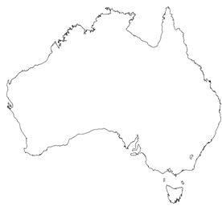 | 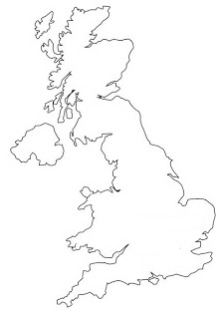 | 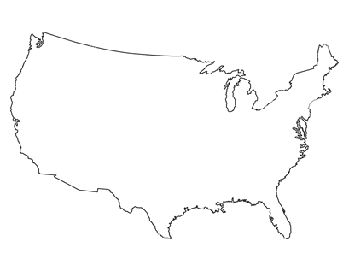 | 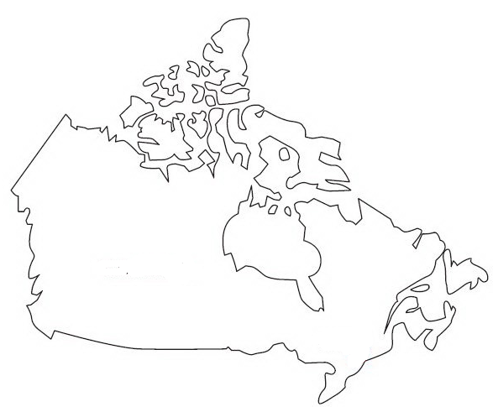
_____________ | ______________ | ______________ | ______________ | ______________
Match the countries with the capital cities.

Ottawa – Washington DC - London – New Delhi – Edinburgh - Pretoria – Wellington - Canberra

USA | ______________________ | Australia | ______________________
Canada | ______________________ | New Zealand | ______________________
England | ______________________ | South Africa | ______________________
Scotland | ______________________ | India | ______________________

Public holidays in English speaking countries 1

Match the name of the holidays with the pictures.

New Year´s Eve – Halloween – St. Patrick´s day –
Thanksgiving – Christmas – Queen’s birthday –
Independence of the USA - Diwali – Boxing day

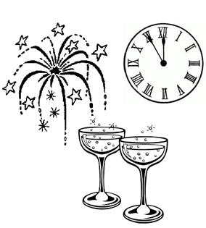 |  | 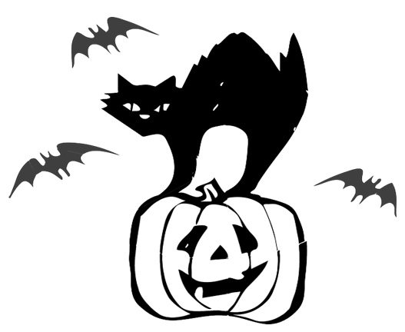
___________________  ___________________ | ___________________  ___________________ | ___________________  ___________________
 |  | 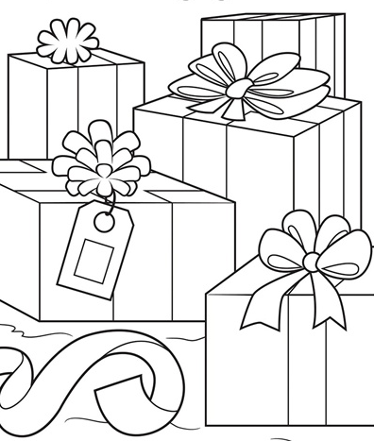
___________________  ___________________ | ___________________  ___________________ | ___________________  ___________________
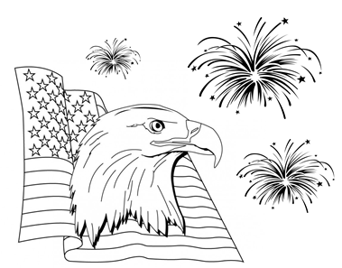 | 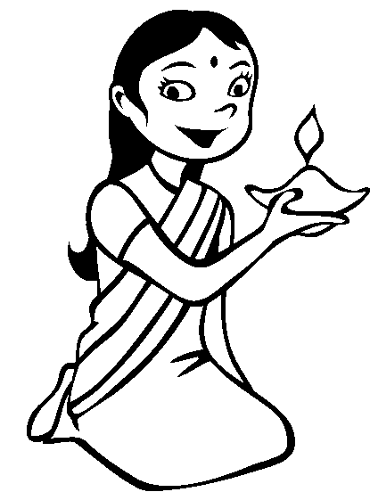 | 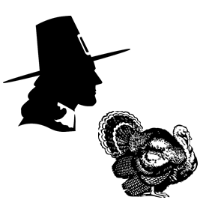
___________________  ___________________ | ___________________  ___________________ | ___________________  ___________________

GUÍA DE ESTUDIO PARA EL EXAMEN DE SEGUNDOS – UNIDAD 4

Choose the correct answer.

1. What _____ she do yesterday?
- do
- will
- did

2. Where did they go last ____________?
- chance
- opportunity
- weekend

3. What did they buy in the supermarket?
They _________ some fruits.
- buy
- put
- bought

4. Where did you go last night?
- I went to the park.
- With Katherine
- On march 2nd

5. Complete the conversation.
A: Hello, Karen! How are you?
B: Hello, Susan! I’m fine.
A: Hey Karen, Where did you go yesterday?
B: I ________ to the park.
A: Really? And what did you do?
B: I ________ volleyball with my friends.
A: Was it fun?
B: Yes it ________.
A: I have class! Good bye! Bye, bye!

- go, went, was
- went, played, was
- was, played, were
PART 2
6. Choose the correct answer in order to complete the chart.

COMPARATIVE CHART | CANADA | MÉXICO
Official languages | English and French | Spanish and English
National animal | Beaver | ?

- Snake
- Frog
- Golden eagle

7. Choose the correct answer in order to complete the chart.

COMPARATIVE CHART | AUSTRALIA | MÉXICO
Capital | Canberra | ?
National sport | Cricket | ?

- Chihuahua, Baseball
- Durango, Basketball
- Mexico city, Soccer

8. Fill in the blanks with the correct connector.
The capital of India is New Delhi _______ its largest city is Mumbai. People eat a lot of rice, spices like curry _______ vegetables. They eat potatoes ________ tomatoes.
- or, or, but
- but, but, but
- but, and , or

