Trabajo de recuperación de inglés – Primer grado
Tema: “Silent films”
Nombre del alumno(a): __________________________________________________
No. Lista: ____Grupo: “____” Turno: ____

I. Label the film genres.
Comedy – Melodrama – Suspense/Horror – Romance
Adventure - War - Western - Sci-Fi

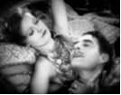 | 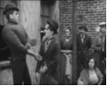 |  | 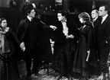 |  |  | 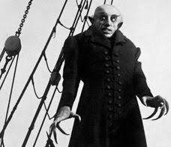
_____________ | _____________ |  | _____________ |  |  | _____________
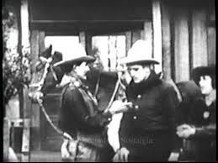 |  | 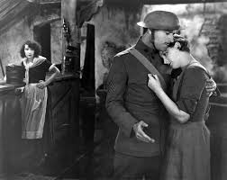 |  | 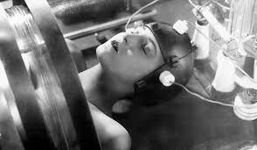 | 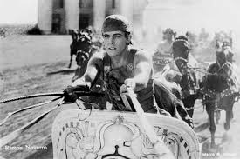
______________ |  | ______________ |  | ______________ | ____________

II. Match the examples with the elements of the script.
- WILLIAM AND KITTY  - (surprised)  - Oh my God! What was that?  - INT. LIVING ROOM - DAY  - He talks to her, but suddenly they hear a strange noise. | - ( ) Character names  - ( ) Dialogues.  - ( ) Action lines.  - ( ) Scene heading.  - ( ) Parenthetical/Emotions.

III. Match the examples with the elements of the script.
- Friend -> Friend  - Man -> Woman  - Dracula -> Hunter  - Secretary -> Visitor  - Young lady -> Police officer | - ( ) You can’t kill me. I’m already dead.  - ( ) Good morning, sir. What can I do for you?  - ( ) You are beautiful! Your lips are perfect.  - ( ) Help me, please! I’m lost.  - ( ) Hey, what’s up dude?

IV. Complete the scripts using the words in the box.

opens - are - horrified - coffin - anniversary

A
INT. RESTAURANT - NIGHT
ANTHONY and SHARON celebrate their __________________in a fancy restaurant.
They _________________ very happy.

B
INT. MANSION - SUNSET
The doorbell rings. CHARLOTTE walks toward the door and _________________ it.

C
INT. CRYPT - NOON
HARKER finds the COUNT DRACULA lying in a ____________________.
He is _________________ and runs away in horror.

