Trabajo de recuperación de inglés – Primer grado
Tema: “Comic strips”
Nombre del alumno(a): __________________________________________________
No. Lista: ____Grupo: “____” Turno: ____

I. Look at the comic strip and identify its parts (1-6).
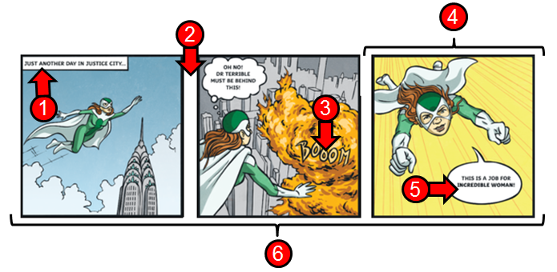
a. Panel. ____  b. Caption. ____  c. Speech balloon. ____ | d. Gutter. ____  e. Onomatopoeia. ____  f. Tier. ____

II. Match the characteristics with the comic genres.
- These comics are funny and entertaining. | - ( ) Superhero.  - ( ) Science fiction.  - ( ) Romance.  - ( ) Horror.  - ( ) Comedy.
- They feature characters such as zombies, monsters, and vampires.
- These comic books involve stories about love and relationships.
- These comics feature characters with extraordinary abilities and costumes.
- They have an emphasis on time-travel, space exploration, aliens, as well as advanced technology.

III. Match the text with the correct speech bubble.
- "I think I'm a fool." | - ( )
- "Help!" | - ( )
- "How are you?" | - ( )
- "Quiet! Or they'll hear us." | - ( )

IV. Match the onomatopoeias with their meanings.
- ( ) The sound of sleeping or snoring.
- ( ) The sound of a big explosion.
- ( ) The sound of a dog barking.
- ( ) It’s used for a sneezing sound.

V. Write "P" for positive or "N" for negative.
1. I think this comic is boring and vulgar. _____
2. It's disgusting because the comic is violent and bloody. _____
3. The story was brilliant and amazing. _____
4. I can't stand this character anymore. _____
5. I love reading this comic. _____
6. I hate the drawings. _____

