Trabajo de recuperación de inglés – Segundo grado
Tema: “Infographics”
Nombre del alumno(a): __________________________________________________
No. Lista: ____Grupo: “____” Turno: ____

I. Label the verbs.
Turn off – Plug in – Set – Insert – Press - Place

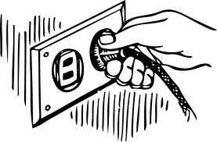 |  | 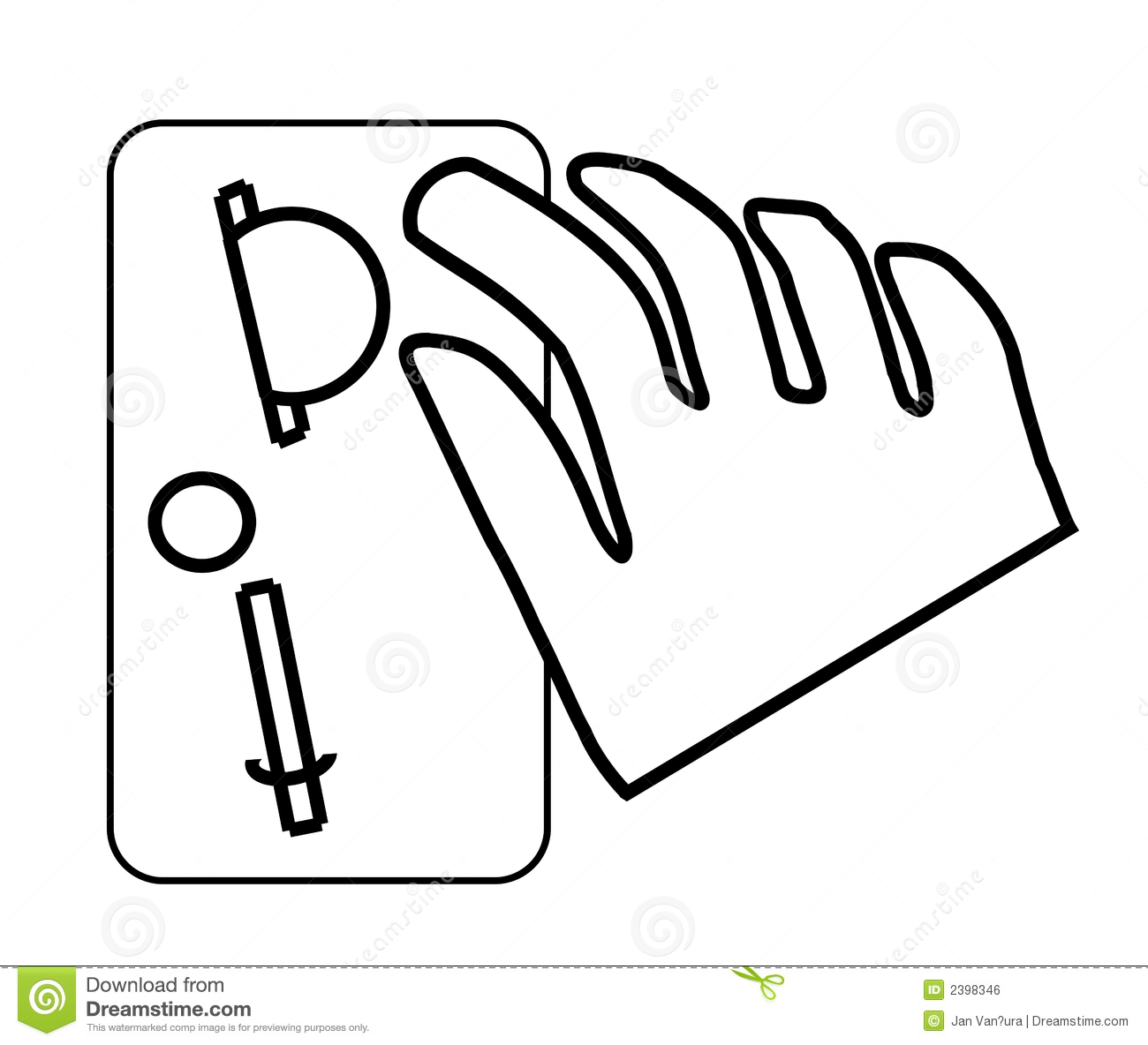
____________________ | ____________________ | ____________________
____________________ | ____________________ | ____________________

II. Match the devices with the instructions.

1 | 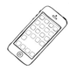 |  | - ( ) Install the driver.
2 | 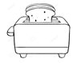 |  | - ( ) Download the app.
3 | 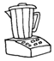 |  | - ( ) Press and hold the ON/OFF button.
4 | 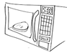 |  | - ( ) Open the door.
5 | 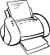 |  | - ( ) Set the temperature.

III. Match the parts with the numbers in the image.
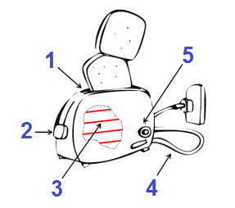
a. Power cord ____
b. Lever ____
c. Bread slot ____
d. Heating elements ____
e. Regulating knob/browning control ____

IV. Put the steps in order (1-4).
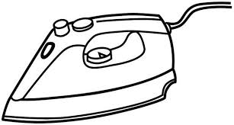
- ___ Then, set the temperature.
- ___ Finally, press down the clothes with the iron.
- ___ First, fill the water tank with water.
- ___ After that, turn on the clothes iron.

