Trabajo de recuperación de inglés – Segundo grado
Tema: “Comparative chart (Short essays about cultural aspects”
Nombre del alumno(a): __________________________________________________
No. Lista: ____Grupo: “____” Turno: ____

I. Label the aspects of culture.
food – music – religion – art – language - clothing

1 | 2 | 3
 |  | 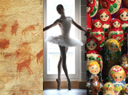
_____________________ | _____________________ | _____________________
4 | 5 | 6
 |  | 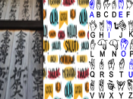
_____________________ | _____________________ | _____________________

II. Match the elements (1-8) of a database of essays.
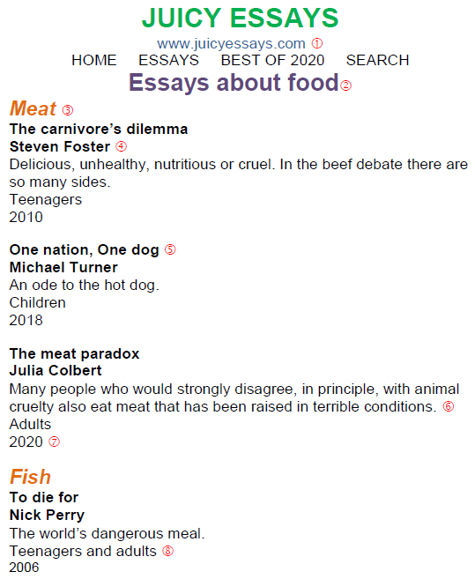 | I. Author ____  II. Web page ____  III. Year of publication ____  IV. Aspect of culture ____  V. Description ____  VI. Essay title ____  VII. Category ____  VIII. Audience ____
III. Fill in the blanks with the following words:
octopus - culture - eat - lot - countries - differences - Torah - prohibited - hoof - fins

There is no country that is exactly the same as others. Every country has its own
1) ___________________, rules and regulations. Mexico and Pakistan are two different 2) ___________________ and both countries have many
3) ___________________ regarding food.

People of Mexico 4) ___________________ almost everything but in Pakistan there is concept of Halal (permitted) and Haram (forbidden). Everything on this earth is permissible, unless evidence is provided for its prohibition. The evidence could be direct text from the 5) ___________________, about specific creatures.

For example, pigs are described as 6) ___________________ and unclean because they have a cloven 7) ___________________ but don’t chew their cud. Fish could be eaten if it had 8) ___________________ and scales, like salmon, carp and trout. This excluded shrimps, prawns, 9) ___________________, clams, crabs, lobsters, oysters, and other seafood, however people in Mexico love eating them a
10) ___________________.
.
IV. Classify the following characteristics of these animals.
Write "C" for cats, "D" for dogs or "B" for both.
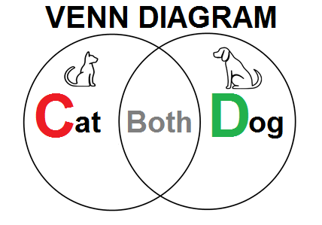 | Characteristics:  1. Bark. ____  2. Mammal. ____  3. Have kittens. ____  4. Meow. ____  5. Climb trees. ____  6. Have fur. ____  7. Pet. ____  8. Have tail. ____  9. Loyal. ____  10. Have puppies. ____

