Trabajo de recuperación de inglés – Tercer grado
Tema: “Poems”
Nombre del alumno(a): __________________________________________________
No. Lista: ____Grupo: “____” Turno: ____

I. Label the elements of a poem.
Verse - Poet – Stanza – Title – Rhyme scheme – Space – Capital letter

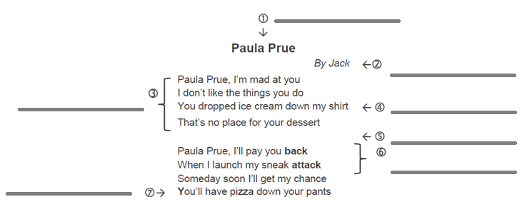

II. Fill in the blanks with the word that rhymes with the given ones.
snail - rat - place - dove – said

- Hat _______________
- Mail _______________
- Love _______________
- Race _______________
- Red _______________

III. Complete the poem.
less - out – king - cry

I really don’t know why
Sometimes I want to 1) __________________
I wish to scream and shout
And let my feelings 2) __________________

I am living like a 3) __________________
But still I miss something
I have nothing 4) __________________
But I can’t feel happiness

IV. Read the poems and identify how you think the poet felt when he wrote it.
angry – happy – grateful - depressed

You would never know it,  The constant pain I feel,  Because in the light of day  It almost isn't real. | You abandon me in my time of need,  Left me with nothing to eat...  I had to survive on my own two feet...  All the money you had, and still you treated me so bad...
1. __________________ | 2. __________________
Thank you  For loving me true,  For being no one but you,  For holding my hand | You came as a ray of light,  Made my life cheerful and bright,  Showering your affection over me  So that my face was full of glee.
3. __________________ | 4. __________________

