Trabajo de recuperación de inglés – Tercer grado
Tema: “Testimony of unexpected situations”
Nombre del alumno(a): __________________________________________________
No. Lista: ____Grupo: “____” Turno: ____

I. Match the unexpected situations and the images on the right.
- My dog is lost.  - My computer crashed.  - He stole a kiss from me.  - I got a bad grade on my test.  - She got pregnant.  - I received a message from a secret admirer.  - My boyfriend cheated on me.  - My phone screen cracked. | - ( ) 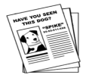 | - ( ) 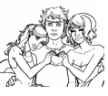
 | - ( ) | - ( ) 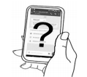
 | - ( ) | - ( )
 | - ( ) | - ( ) 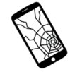

II. Match the descriptions (1-4) with the unexpected situations.
#1  I went to a birthday party I was invited to with a friend. The host invited a bunch of people that he didn’t know. Around 3 am I decided to leave and was already outside when I realized my wallet was gone. There is no way I could have lost it as I saw it when I closed my bag when I arrived.  #2  Few months ago I was walking down the street with my iPad and my iPhone in the same hand and accidentally I dropped both devices. The screens cracked in one fall.  #3  Last night, I was downloading videos on the dark web and my laptop suddenly crashed with a blue screen and a stop code message appears.  #4  The weekend was filled with sadness, looking at pictures and videos about him. Our cat, Blacky, died suddenly. It has been very traumatic for my little sister. She really loved him. | - ( ) Broken devices.  - ( ) Pet dead.  - ( ) Bad grade.  - ( ) First kiss.  - ( ) The theft.  - ( ) The virus
III. Read each conversation and identify the feelings involved. Match them (1-3) with the images on the right.

#1  A: Who’s that girl? She’s really gorgeous.  B: Her name is Audrey. She is my girlfriend.  A: Are you kidding me?  A: No. I’m not kidding. She is from France.  B: Wow! I can’t believe it. You are so lucky!  #2  A: Sheila. Do you know how late it is?  B: My fault. I didn't realize what time it was.  A: You should have called and let me know.  B: That's true. My bad for not calling.  A: If you do this again, don't even bother coming home.  B: You're going to kick me out over this?  A: Exactly, maybe that'll teach you to respect my rules.  #3  A: Tania, I can't find my purse!  B: What? What was in your purse?  A: It contained my wallet and passport. Oh my God!  B: Selena, how much money was in your wallet?  A: $2000 dollars. My parents are gonna kill me! | - ( )
 | - ( )
 | - ( )

IV. Read the story and circle the correct answer.

Yesterday at school my closest friend Sarah with who I share everything, told me she's four months pregnant. I pretended to be happy for her but I was shocked to hear that. It’s not that I’m not happy for her. I am… jealous. Our friendship, as we knew it, has changed irrevocably. I hate the thought of us not being in the same place, doing the same things. I felt left behind, betrayed, and abandoned. She is going to want to be alone after the birth and I'm really going to miss her. | 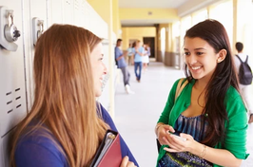

1. What happened?
a) Sarah's best friend is pregnant.
b) She is jealous because she wants a baby, too.
c) The girl thinks she's losing her best friend forever.

2. How did Sarah's friend feel?
a) Excited.
b) Angry.
c) Confused.

3. Why did she feel betrayed?
a) She felt like the baby is replacing her.
b) She has trusted her with her secret but she told it to others.
c) She's having a baby with her boyfriend.

